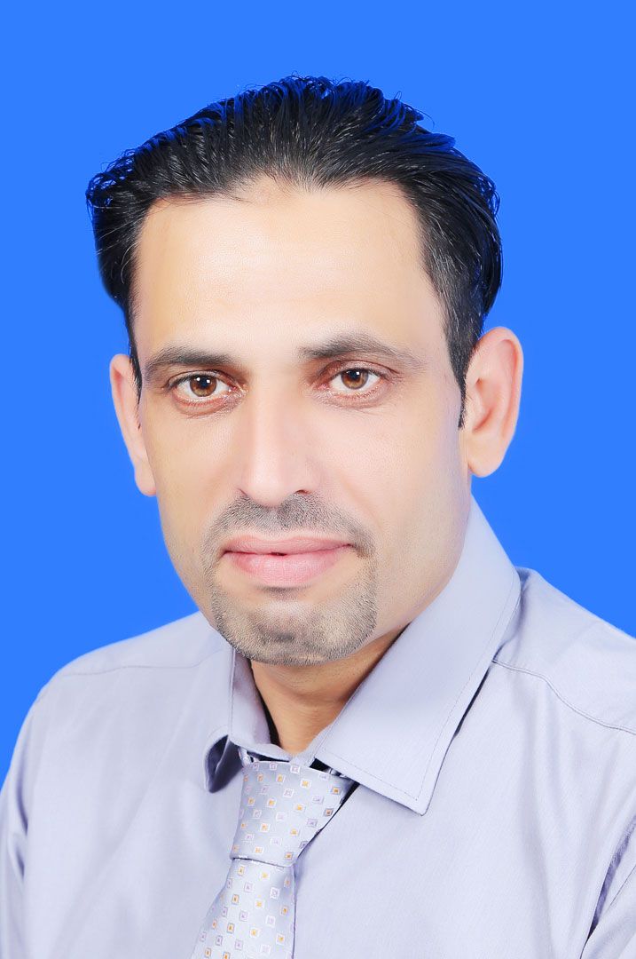
C.V

Name: Omar Rashid Dawoud Sadeq, M.D., Ph.D.

Specialization: General and Clinical Pharmacology.

Assistant Head of the Basic Medical Sciences Unit.
Head of Pharmacology Division of the Basic Medical Sciences Unit, Faculty of Dentistry. Arab American University- Palestine (AAUP).

Contact information:

- Mailing address: omar .sadiq@aaup.edu
- Home phone: +972-09-238-61-03
- Mobile phone: +972-599-03-99-74

Personal information:

- Nationality: Palestinian.
- Place and date of birth: Nablus, 05-08-1972.
- Marital status: married with 3 children.
- ID No: 904653748.
- Passport ID: T 456508.
- Address: Nablus, Circle of Asira.
- Arabic language: Native language.
- English language: Excellent (writing, reading and speaking).

Academic Qualifications:

- Ph.D., in Medicine (General and Clinical Pharmacology) - National Research Center for Biologically Active Compounds (NRC BAC), Moscow-Russia (2003).

- M.Sc., in Clinical Endocrinology- Kharkov Medical Academy, Ukraine- 2000.

- B.S., in General Medicine- Zaporozhye State Medical University, Ukraine- 1998.

- A Member of Jordan Medical Association, Jerusalem -Amman. (Reg. No: 4529).

Experiences:

- Worked as a resident doctor in hospitals of Kharkov Medical Academy at the department of Endocrinology (1998-2000).

- Worked as a Teaching Assistant of pharmacology, anatomy, embryology and physiology at the department of National University of Pharmacy, (2000-2003).

- Certificate of Junior Lectures School: Methodology of medical teaching process, psychologic approach and evaluation of students which include the most appropriate manners to teach students, using several methods such as laptop, projectors and figures, this process was supplemented by physiologic and pharmacologic experiments on several species of pathologic-induced animals, (2001-2003).

- Shared in several medical and pharmaceutical conferences: (Kiev October 2000, Donecek, December 2000, Odessa November 2003 and Moscow February 2003).

- Assistant Professor as a part timer of General and Clinical Pharmacology at faculty of medicine of An-Najah National University, (September 2006).

- Assistant Professor as a full timer of General and Clinical Pharmacology and General Pathology at faculty of dentistry of Arab American University- Jenin (2008- up today).

- Assistant Professor as a part timer of Pharmacology, Anatomy and Basic Physiology, Pathology and Internal Diseases at Nursing and Anesthesiology departments of Alrawda Technical Community College and Andaleeb Union Society , (September 2005-2008) .

- I prepared materials of Basic and Clinical Pharmacology for medical students of An-Najah National University, (2006).

- I prepared material of anatomy, physiology, pathology, general pharmacology and internal diseases for medical, and allied medical students of anesthesia of Anajah University, Arab American University and Alrawda Technical Community College, (2006-2010).

- Publications:

- Omar Rashid Sadeq *, Mahmoud Abu Mowais, ERYTHROMYCIN: ITS GLYCEMIC EFFECT IN AN INFECTIOUS PATIENTS, INTERNATIONAL RESEARCH JOURNAL OF PHARMACY, Volume 9, Issue 9, Sep 2018, www.irjponline.com, ISSN 2230-8407, pages:25-29.
- Omar Rashid Sadeq, Hepatotoxicity associated with piroxicam therapy., Journal of Pharmacy Research | Vol 12 • Issue 4 • 2018., jprsolutions.info ISSN: 0974-6943, pages: 554-559.

- Omar Rashid Sadeq, The Action of Amoxicillin-Clavulanate on Hepatocytes, American Journal of Pharmacological Sciences, 2017, Vol. 5, No. 1, 8-10 ,Science and Education Publishing DOI:10.12691/ajps-5-1-2.
- OMAR RASHID SADEQ & MAHER M.A JARBAWI, THE EFFECT OF INDOMETHACIN ON GLUCOSE SERUM, MPACT: International Journal of Research in Applied, Natural and Social Sciences (IMPACT: IJRANSS) ISSN(P): 2347-4580; ISSN(E): 2321-8851Vol. 5, Issue 4, Apr 2017, 1-8 © Impact Journals.

- Dr. Omar Rashid Sadeq* MD., Ph.D THE EFFECTS OF MINI-DOSE ASPIRIN ON HEPATIC FUNCTIONS. World Journal of Pharmaceutical Research, Vol 6, Issue 03, 2017.PP 157-160.www.wjpr.net.

- Azzaldeen Abdulgani , Omar Sadeq, Jabareen Ali , Ziyad Kamal Mohammad , Kontoes Nikos,Thomy Kouremada, Georges Chlorokostas , Muhamad Abu-Hussein*., Continuing Aspirin Therapy Does Not Increased Risk Of Bleeding For Patients Undergoing Minor Dental Procedures, IOSR Journal of Pharmacy and Biological Sciences (IOSR-JPBS) e-ISSN:2278-3008, p-ISSN:2319-7676. Volume 11, Issue 2 Ver. III (Mar.- Apr.2016), P 15-23 www.iosrjournals.org.
- DR. OMAR RASHID SADEQ., DR. ISMAIL AL-MASRI AND DR. KHALIL AL-KHARAZ THE EFFECT OF IBUPROFEN ON HEPATIC GLUTAMIC PYRUVICTRANSAMINASE (SGPT), GLUTAMIC OXALOACETIC TRANSAMINASE ( SGOT) AND ALKALINE PHOSPHATASE (ALP) IN DENTAL PATIENTS. International Journal of Pharma and Bio Sciences, 2014 Oct, 5 (4) ISSN 0975-6299, pages 689-691.

- Omar Rashid Sadeq., Maloshtan L.N., Poltorak V.V., Study of the hypoglycemic action of adiachromium substance using the model of hereditary insulin-independent diabetes mellitus in the obese mice// Bukovinsk medical bulletin, 2003-Volume 7, N0. 1-2 Pages 103-104.

- Omar Rashid Sadeq., Maloshtan L.N., Adiachromium is an original synthetic preparation of the hypoglycemic action. Transactions of the III International Scientific –Practical Conference. P.1-X: Publishing House of the NaoF, 2003.-Page.199.

- Omar Rashid Sadeq., Maloshtan L.N., Maloshtan V.A., Influence of adiachromium on the experimental hyperglycemia in rabbits/ Digest "Medicine for the man". Kharkov, 2002. Volume XVII, No. 2- pages 188-191.

- Omar Rashid Sadeq., Maloshtan L.N., Experimental study of ulcerogenic properties of new hypoglycemic adiachromium preparation// Bulletin Vinnitsa State Medical University. 2002- Pages. 184-185.

- Omar Rashid Sadeq., Maloshtan L.N., Study of the specific activity of adiachromium on the experimental model of diabetes mellitus //Transactions of the all-Ukrainian Scientific & Practical Conference.- Kharkov, 2002.-Pages 168-169.

- Omar Rashid Sadeq., Maloshtan L.N., Maloshtan V.A., Search of the substances with hypoglycemic prosperities among the benzopyrane derivatives //IX National congress, "Man and medicine" Transactions- Moscow, 2002. Page- 655.
- Omar Rashid Sadeq., Maloshtan L.N. Toxicological study of the adiachromium hypoglycemic preparation/Digest "Medicine for the man". Kharkov, 2001. Volume XVI, No 1-2- pages 352-358.

Skills:

- Computer skills.

- Teaching and lecturing practical training of basic medical sciences.

- Following up the periodicals especially the medical researches of physiology and pharmacology in the following medical journals: British Journal of Pharmacology, Canadian Journal of Physiology and Pharmacology, European Journal of Clinical Pharmacology, American Fundamental and Clinical Pharmacology and American Journal of Therapeutics.

References:

- Professor Dr. Mahmoud Abu Mowais, Head of basic medical sciences unit of Arab American University, Palestine, (AAUP) Tel-. +970 4 2418888 Ext. Number: 1566, mahmoud.abumouis@aauj.edu.

- Dr. Maher Jarbawi, Associate Prof. Former Dean of faculty of Dentistry of AAUP, Tel-. +970 4 2418888 Ext. Number: 1501. Email: maher.jarbawi@aauj.edu

- Dr. Hussni Maqboul, Former dean of medicine faculty of An-Najah National University, Tel. -0599-20-61-14.

