Curriculum Vitae 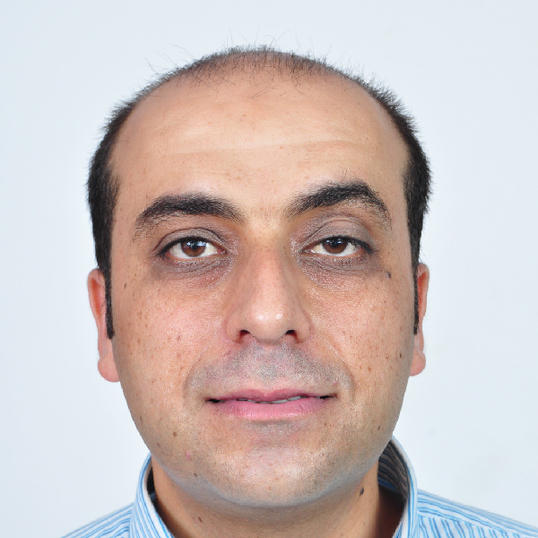

- General Information

Name | Ahmed Ali Jarrar
Gender | Male
Date of Birth | 19-2-1981
Nationality | Palestinian
Education Level | Jordanian &Palestinian Board in Periodontology ,  MSc Dent (Periodontology and Oral Medicine)
Mobile | +970-59-5319794
E-mail | Drjarrar@yahoo.com

Education

Level | Duration | School
Jordanian Board in Periodontology | 2016 | Jordanian Medical Council, Jordan
Palestinian Board in Periodontology | 2016 | Palestine Medical Council, Palestine
The Saudi Commission for Health Specialties license as Registrar in Periodontology | 2009 | Saudi Commission for Health Specialties, KSA
MSc Dent (Periodontology and Oral Medicine) | 2005-2007 | University of the Western Cape, Cape Town, South Africa
Bachelor of Dental Surgery (B.D.S) | 1999-2004 | University of Jordan, Jordan.  Grade V.Good
School Diploma | 1998-1999 | Al-Husein Bin Ali School, Hebron, Westbank. Grade 98.6%

Clinical Experience

Field
Working at tygerberg hospital, Grooteschuur hospital and Mitchells Plain dental center as part of M.S.c Dent degree at the University of the Western Cape. (Feb/2005 – Aug/2006).
Working as a part time lecturer at the University of the Western Cape.
(Feb/2005 – Aug/2006).
Thesis Title: Comparison of an Essential Oil mouth rinse and Chlorhexidine on 4-day interproximal plaque regrowth (2005 - 2006).
Working as a Part-time lecturer at Al-Quds University, Abudees, West bank, Palestine
(Sep/2006-Jan/2007).
Working as a Periodontist at Dr. Saud Naqshabandi Orthodontic and Dental clinics, Riyadh, KSA (May/2007-Jan/2010).
Working at Saudi National Guard (King Abdul Aziz Medical City), Al-Ihsaa, KSA (Sep/2010-Nov/2010).
Working as a Periodontist at Saudi Ministry of Health (East Riyadh specialist Dental Center, King Saud Medical City and Al-Yamamah hospital) , Riyadh, KSA (Dec/2010-Sep/2014).
Working as a lecturer at oral and maxillofacial and periodontology department at the Arab American University of Jenin. (Sep/2014 – Sep/2016).
Working as an Assistant Professor at oral and maxillofacial and periodontology department at the Arab American University of Jenin. (Oct/2016 – Present).

- Courses and Conferences

Course or Conference | Provider
Cape society of dental implant annual meetings  1st (Mar-2005) and 2nd (July-2005) | Cape society of dental implant, Cape Town – South Africa
Implant Course (Aug-2005) | Bicon Implant Company- South Africa
Implant Course (Oct-2005) | Nobel Biocare Implant Company- South Africa
Periodontology Today Course (Oct-2005) | The South African Society for Periodontology, South Africa
Implant Course (May-2007) | Oraltronics Company- Jordan
The 12th Saudi International Dental Meeting and Contemporary Fixed Restorations Course (Apr-2008) | King Saud University
The 20th International Dental Conference (New Dental Era) (Apr-2009) | King Saud Bin Abdulaziz University for Health Sciences and Saudi Dental Society
The 23rd International Dental Conference (Emerging Horizons in Dentistry) (Feb-2012) | King Saud University and Saudi Dental Society
Cardio Pulmonary Resuscitation Course (Dec-2013) | Saudi Heart Association and king Saud Medical City
The 24th International Dental Conference (Jan-2013) | King Saud University and Saudi Dental Society

Presentations

I presented my thesis titled (Comparison of an Essential Oil mouth rinse and Chlorhexidine on 4-day interproximal plaque regrowth) at the 40th Scientific Meeting of the IADR (SA Division) (Sep-2006), (Poster Presentation).

- Publications

1 | Effect of an Essential oil mouth rinse (Listerine®) on interproximal plaque regrowth compared to Chlorhexidine and sterile water: a randomized controlled, three periods cross-over, clinical trial. Pakistan Oral & Dental Journal Vol 34, No. 1 (March 2014).

Languages

- Arabic: Mother Language.
- English: Conversation, reading, writing (Excellent)

Skills

- Microsoft Office.
- Excellent Communication skills.
- Familiar with the World Wide Web.
- Highly self learning.

Ambitions

- To become a successful man.
- To assist the growth of an organization.

References

- Prof. L X G STEPHEN, Head of Department of Oral Medicine and Periodontology, University of the Western Cape, Cape Town, South Africa. E-mail: lstephen@uwc.ac.za.

- Dr. Maher Al-Abdulkarim, Head of Periodontology Department at East Riyadh Specialized Dental Center, Saudi Ministry of Health, Riyadh, KSA. Consultant in Periodontology, American Board of Periodontology. Phone no.: 00966-54-9554955.

