PERSONAL INFORMATION | Methqal Ghalib Naji Daraghmeh
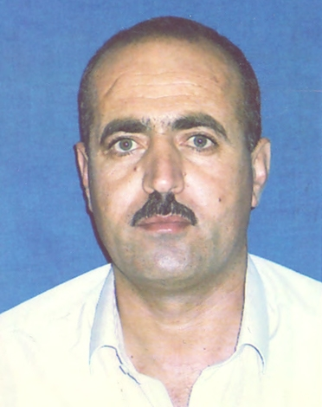 |   Department of Mathematics and Statistics ,The Arab American University –Jenin (AAUJ)

0097292573646
00972599700784

Methqal.daraghmeh@aauj.edu
Sex :Male
| Date of birth: 13/5/1971
| Nationality :Palestinian

Studies applied for :Mathematics and Applications

(2005 –present)  WORK EXPERIENCE | Lecturer  Department of Mathematics ,Arab American University-Jenin, Palestine, Tel:+970510810
(2005 –present)  WORK EXPERIENCE | - Teaching various courses in mathematics such as Cal(I),Cal (II),Cal(III),Linear Algebra(I),Mathematics for Medical student, Business Mathematics, Engineering Mathematics(I),Mathematics for chemistry student ,Math. for IT, Numerical Analysis(I)  - Teaching Assistance: physics Department at aauj from (2000 – 2005)  - Teacher: High school, Tubas Secondary school ,Palestine( 1995-2000)
Research Interesrs Numerical Analysis and Approximation, Mathematical Physical, Ordinary Differential Equations and partial Differential

Equations , Monte carlo Method
EDUCATION AND TRAINING

(2003 -2005) M.Sc. in Computational Applied Mathematics
Department of Mathematics , An- Najah National University .Nablus ,Palestine
The sis title: Numerical Methods for Solving Elliptic Boundary – Value Problems
. Supervisor: Dr.Samer Matar
Study Language: English
(1990 – 1994) B.Sc. in Science field of specialization :Physics
Department of Physics , An Najah National University Nablus, Palestine
- June 1989 Tubas Secondary Boy's School/Branch: Science
PERSONAL SKILLS
[Remove any headings left empty.]
Mother tongue(s) | Arabic
Other language(s) | UNDERSTANDING |  | SPEAKING |  | WRITING
Other language(s) | Listening | Reading | Spoken interaction | Spoken production
Replace with language | B1/2 | C1/2 | B1/2 | B1/2 | C1/2
Levels: A1/2: Basic user - B1/2: Independent user - C1/2 Proficient user
Common European Framework of Reference for Languages

Communication skills | - Verygood communication skills gained through my experience as university Lecturer and school Teacher

Committees | - Union Committee
Job-related skills | - Clubs Committee ( Head : 2010 – 2912 and 2014/ 2015)  - Social Committee  - Disciplinary Committee (2011- until now)

Computer skills | - good command of Microsoft Office™ tools and Matlab package

Driving licence | - B

ADDITIONAL INFORMATION

Projects and Activities  Conference  Papers | - Some Numerical Methods for solving Partial Differential Equations Using Matlab  - Euler and Runge-Kutta Methods for solving Ordinary Differential Equations Using Matlab  - Finite Difference Approximations To Heat Equation and Ellipticequations  - Power Method for finding Eigen value and Eigen vectors  - Preparing Numerical Analysis (I) as E-Learning course at aauj.  The Fifth Palestinian Conference on Modern Trends in Mathematics and Physics. July 31th – August , 2016, AAUJ, Jenin, Palestine. Poster: The Optimum Maximum Allowed Displacement in Monte Carlo Simulation of One-Component Plasma.  - Iyad . Suwwan, Methqal.Daraghmeh ,AbedelHaleem.Zeqan. Analytical Solution of Frenet-Serret System of Circular Motion Bodies. Journal Applied Mathematical Science,Hikari,vol,7,2013,no,143,7143-7150  - Mohammad M. Abu Samreh , Anan Hussain, Mithqal Daraghmeh and Abedelrahman Abulebdeh. Indoor Radon-222 Concentration levels Measurements and Exhalation Rates Calculations in some Offices and rooms of AAUJ during the winter and spring Seasons of the year 2014,AAUJ Journal.  3)Mohammad Abu-Samreh^{1,2*}, Anan A. Hussain¹, and Methqal Daraghmeh³ ,  Assessment of indoor radon concentration levels and annual effective doses in dwellings of Tubas Governorate, West Bank, Palestine  4) Iyad Suwan, Hayel Hussein, Anan Hussein, Methqual Daraghmeh .The Optimum Cut-off Radius in Monte Carlo Simulation of Yukawa Potential " Submitted to the Journal of Physics . Conference Series (JPCS).

References 1) Prof.Ali Zaidan , President of Arab American University
2) Dr. Samer Matar Department of Mathematics,An Najah National University
(Samatar@najah.edu)
3) Dr Iyad Abu Je'ib, Department of Mathematics and Statistical, AAUJ (IJeib@aauj.edu)

