Curriculum Vitae 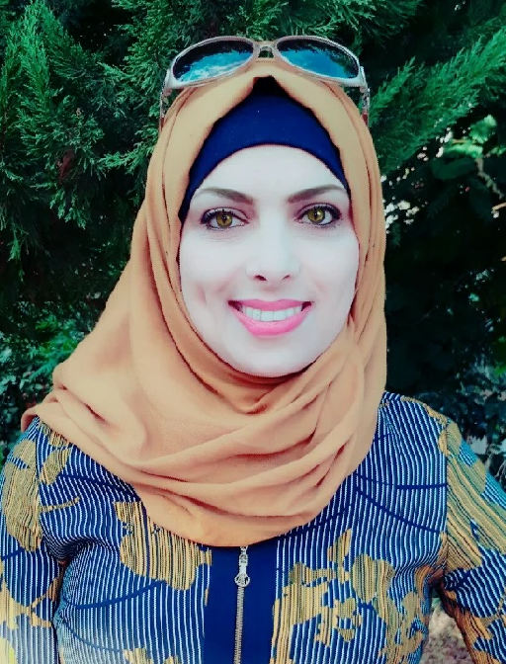

General information

Name: Jamila Daraghmeh
Date of birth: 28 June, 1982
Nationality: Palestinian
Marital status: Married
Office Address: Faculty of Arts and Sciences, Biology and Biotechnology Department, Arab American University- Jenin/Palestine.
Phone number: 092-573267. Mobile: 00972598741833
E-mail: jsameer@aauj.edu; jamila.daraghmeh@aauj.edu

Education

6/2000: Tawjehi; Araba Secondary School
9/2000- 6/2004: B.Sc. in Biology and Biotechnology, Arab American university- with excellent standing
2/2010- 12/
2011: Master degree, Biology and Biotechnology (Thesis in Molecular Biology, Germany) An-Najah University (ETS) Family Factors: Role and Cooperative Interactions in Prostate Cancer.

Practical Experience

10/2004-10/2005 teacher assistant in biology labs, Arab American U university
10/2005-10/1012 technician in Biology labs, Arab American University
10/2012 until now-instructor in biology and biotechnology department

Computer Skills

MS Windows, MS Word, e-mail, Internet
24 hours training (MS office applications 2007)

Other Experience

      - Microbiological techniques: media preparation, maintaining stock culture, performing biochemical tests (on bacteria).
      - Genetics techniques: karyotyping of human blood cells, classical genetics (culture preparation of drosophilae and maintaining stocks, etc…)
      - Handling with autoclave, light-microscope, incubators, centrifuge, Elisa, and spectrophotometer.
      - Molecular techniques: gel (agarose) electrophoresis, DNA and RNA extraction , ,PCR,RT-PCR
      - Microbiological techniques: Media preparation, maintaining stock culture, performing biochemical tests.
      - Cell Culture techniques: Mammalian (Transient & stable) cell transfection, Maintaining of various types of cell lines, Cryopreservation, Cell viability tests such as MTT and, preparing media, inverted microscope, cell counting.
      - Research work in study the effect of certain Palestinian plants on prostate cancer cell lines.

Publication

Ahmad, MA, Naji, Ramadan, Daraghmeh, A, J, Jaradat, and N, I (2014) Screening of Rutin from Leaves Extracts Of Wild Plants In Palestine. United States of American Research Journal 2: 22-27.

Jamila Daragmeh¹, Waseim Barriah², Bashar Saad^{1,2} and Hilal Zaid^{1,2} (2016) Analysis of the PI3K pathway components in human cancers.

Saad B1,2*, Embaslat WH1, Farich BA1, Mahajna S2, Azab M2, Daragmeh J2, Khasib S1 and Zaid H1,2 .Hypericum triquetrifolium Extracts Modulate IL-6, IL-10 and TNF-α Protein and mRNA Expression in LPS-Activated Human Peripheral Blood Mononuclear Cells and THP-1-Derived Macrophages.
Conferences
- Shahinaz Mahajnaª, Hilal Zaid^{a,b}, Jamilla Daragmeh^{b} and Bashar Saad^{a,b} In vitro Evaluations of Cytotoxicity and Anti-inflammatory Effects of Peganum harmala Seed Extracts in THP-1-derived Macrophages The 15th International Congress of the International Society for Ethnopharmacology”Petra-Jordan May, 5th- May, 8th (2015).
- Jamila Daragmeh¹, Waseim Barriah², Bashar Saad^{1,2} and Hilal Zaid^{1,2} (2015) Analysis of the PI3K pathway components in human cancers
2nd International Conference on Science, Technology, Engineering and Management 2015

Main Responsibility

- Teaching biology for medical students’ course.
- Teaching labs. General biology, Biochemistry, plant cell culture, and molecular biology.
- Advising faculty on experimental work and participating in faculty meetings for laboratory courses.
- Maintaining facilities and equipment and procuring supplies.
- Supporting the on-going development of the laboratory

Languages
Arabic (mother language)
English (very good):
- 24 hours training course in interactive English
- Certificate in English proficiency

