The Impact of Mobile Telephony on Developing Countries Enterprises: A Palestinian Case Study

Khalid S. Rabayah,
k.rabayah@gmail.com
ICT4D research center, Arab American University, Jenin, Palestine
Khalid Qalalwi
kqlalweh@pcbs.gov.ps
ICT Department, Palestinian Central Bureau of Statistic

Abstract
This paper aims to explore the use and impact of mobile telephony on the performance of companies in developing countries, through a nationwide survey comprised of thousands of enterprises representing a true sample of the business sector in Palestine. This paper complements studies that make the linkage between mobile communications and economic activities at micro or enterprise level. It analyses the adoption patterns and rational behind these patterns as revealed by the business owners and managers of Palestinian enterprises. Porter’s value chain is used as a framework to assess the impact of mobile telephony in work processes.
The survey covered thousands of enterprises of all sizes and economic activities, selected to embody a representative sample of the Palestinian business sector. It further explores the views of the owners and managers of these enterprises regarding the use of ICTs. The study reveals that mobile phones have meaningfully enhanced internal processes and the overall value chain. Most notably, mobile phones were effective in bridging the information and connectivity gap businesses in developing countries ordinarily suffer.
The study has also found that small and micro enterprises gain from the use of mobiles the same as what large enterprises do, especially in mainstream operations like marketing and sales, information flow, and provision of customer services. This is happening at the time when there is a huge difference in resources between the two categories of enterprises. The study came to conclude that mobile benefits are not favoring one business sector from the other, in the sense that all business sectors are capable of tailoring mobile phone services to suit their needs.

Keywords: mobile telephony, development, enterprises, developing countries, m-commerce, SMEs.

1. Introduction
The study comes to fill in a gap in this research area as the number of studies investigating the impact of mobile telephones on the performance of firms is very limited, particularly in developing countries (Donner & Escobari, 2010). In their review of mobile use by micro and small enterprises (MSEs), Donner and Escobari (2010) refer to various open issues that warrant attention, for instance, which kind of SMEs gain more from the use of mobile phones, and whether enterprises are using mobiles as a transformational agent or using them to magnify existing gains in their businesses. Furthermore do enterprises use mobiles to find new customers and expand their markets? In this study we’ll try to address some of these issues by considering a nationwide study that encompasses thousands of enterprises of diverse economic activities.
Researchers have so far failed to find explicit correlation between the use of Information and Communication Technologies (ICT) and economic growth, particularly in the context of developing countries (David, 2000; Schreyer, 2000; Gordon, 2002; Stiroh, 2002). Researchers sought to justify this ambiguity in the role of ICT in economic and social development by the rapid pace at which the ICT technologies are evolving, the lack of rigorous assumptions, the relative novelty of these technologies, and the hype and excitements these technologies are causing. And they tend to maintain that no conclusive thesis can be asserted as of the role of ICT in economic and social development in the context of developing countries, (Unwin, 2008; Heeks, 2002; Roman, 2003; and Kenny, 2006).
Vagueness in the role of ICT in economic development inspired research about the role of ICT at the corporate and microeconomic level. Several studies addressed the impact of ICTs on the performance of enterprises, (Lucchetti and Sterlacchini, 2004; Love et al., 2004; Schulbert, 2006, 2007; Koellinger, 2006; Morikawa, 2004; Gregor et al., 2004; Walsham & Sahay, 2006; Avgerou, 2006; Krishna & Madon, 2005). Some of these studies revealed sound correlation between level of ICT diffusion and the enterprise efficiency and competitiveness. Some correlation between the enterprise size and business activities on one side and the penetration level and complexity of ICT systems on the other side was also reported.
A number of studies focused on certain types of ICT technology – mobile phones and the Internet - their penetration and use by enterprises in developing countries. The rapid dissemination and extensive use of mobiles in the developing societies have led some researchers to predict that mobile phones may generate the same impact landline had for developed countries decades earlier (Waverman et al., 2005). UNCTAD (2009) predicted that mobile phones would likely have greater impact on economic growth in developing than in developed countries since developed countries are well covered by landline telephony. Castells (2007) addressed the social implications of use of mobile technologies in developing countries.
Donner and Escobari (2010) summarizes 14 studies that address the use of mobile phones by MSEs in developing countries. They noted that there is strong evidence that mobile phone use can benefit SMEs. However, the impact is verified in amplifying existing resources, in searching for relevant information and in enhancing profit opportunities rather than as a transformational agent. Most studies dealt with mobiles in the context of marketing and sales and as an effective tool to keep contact between customers and suppliers (Abraham, 2006; Aker, 2008; Donner, 2006; Esselaar et al., 2007; Frempong et al., 2007; Jagun et al., 2008). Mobile phones can help achieve better prices for services and decrease price dispersion (Jensen, 2007). He studied the impact of mobile on the fishing industry in the Indian district of Kerala, and observed that mobile has posted the fishermen profits by an average of 8% as they began using their mobile phones. Yet in the same study, Jensen found that consumer prices for fish dropped by 4%. Jagun et al. (2008) classified impact of mobile for SMEs into two categories; process benefits, where gains were reported, such that process time is significantly reduced and structural benefits, where there were no signs of any gain in that regards. Hughes & Lonie (2007) gives the example of a mobile-based money transfer service implemented in Kenya, named M-Peas, in cooperation with the mobile operator Safaricom. The initiative attracted 6.5 million customers by mid 2009, with 2.5 million transactions daily in Kenya alone.
Researchers contrasted use and impact of mobile with fixed telephony (Abraham, 2007; Jensen, 2007). The mobility feature greatly enhances the temporal and spatial domain that people can communicate within, so that they connect people to people not places to places. This has greatly impacted the way people interact socially and do business (Aker, 2008; Overå, 2006).
Several studies can be found on specific countries such as Boadi et al. (2008) who studied the impact of mobile use on farmers and fishermen in Ghana. They found that mobile or m-commerce facilitates cost reduction for farmers and fishermen, and offers them opportunities for deepening internal and external business relationships.
In the next section a brief description of the Palestinian business sector, including the distribution of enterprises on various economic activities and in terms of number of employees will be reviewed. Section three reviews the research methodology used to conduct the study. Section four addresses the adoption patterns and impacts of the use of mobile on the function and business activities of Palestinian enterprises. Section five focuses on the interpretation of the survey results, and finally a conclusion is drawn.

2. Overview of Palestinian Enterprises
Palestine is an exceptional place with unique economical and political complications resulted from the elongated military occupation by Israel. The aim of this section in the context of the study is to place ICTs in the context of the Palestinian enterprises.
The economic status of the Palestinian Territories is contingent to political developments. In 2000 after the second Intifada (Uprising), the typical earnings for Palestinians have fallen by about 30%, bringing almost 50% of Palestinians below the poverty line of 2 USD/day (IFC, 2007). In May 2006 and following the adjustment of the poverty line to be 2.7 USD per day, 70% of Palestinians fell below the poverty line. In the same period unemployment approached 50% (IFC, 2007).

Table 1: Percentage Distribution of Enterprises by Economic Activity and Region, 2007, (PCBS, 2007)
Economic Activity | Region |  |  | Number of Enterprises
Economic Activity | West Bank | Gaza Strip | Palestinian Territory | Number of Enterprises
Industrial | 17.1 | 13.4 | 16.0 | 16,855
Constructions | 0.6 | 0.9 | 0.7 | 699
Wholesale and Retail Trade | 56.1 | 59.6 | 57.1 | 60,088
Transportation and Communication | 24.5 | 23.8 | 24.3 | 25,523
Financial Intermediation | 0.9 | 1.6 | 1.1 | 1,164
Services | 0.8 | 0.8 | 0.8 | 854
Total | 100 | 100 | 100 | 105,183

Table 1 above, details the distribution of enterprises in regards to their economic activities and locality. About 60% of enterprises are small shops in retail and whole sale, with total employees’ number of 60,000. Most of them are internationally classified as micro or informal enterprises. Informal enterprises have one or no employees as they are run by the owner and some of his family members, do not pay taxes, and mix business with personal finances. Transportation and communication enterprises fall next to retail and whole sale, with a percentage that mounts to 25%. Small percentage is involved in telecommunication activities. Industrial enterprises occupy the third rank with total number of 16,855 enterprises and percentage of 16%. Construction, financial and services contribute less than 1% each with employment size around 1,000 employees (PCBS, 2007).

Table 2: Percentage Distribution of Enterprises by Number of employees and Economic Activity, 2007
Economic Activities | Number of Employees |  |  | Total
Economic Activities | 0-4 | 5-9 | 10+ | Total
Industrial | 77.1 | 15.1 | 7.8 | 100
Construction | 66.7 | 21.2 | 12.2 | 100
Retail and Wholesale | 95.2 | 3.8 | 1.0 | 100
Transportation and Communication | 86.5 | 8.7 | 4.8 | 100
Financial | 66.6 | 20.8 | 12.6 | 100
Services | 70.1 | 11.8 | 18.0 | 100

Table 2 details the distribution of enterprises according to the employment size across the different activities. In total there are 89.5% of enterprises with employment size less than 5. 7.1% of all enterprises are employing between 5 and 9 persons, and 3.3% of all enterprises are hiring 10 or more employees. Enterprises with 10 or more employees are found in the service activity, financial and construction, than other activities.

3. Research Method
The scope of the study involves all private firms that are economically active in Palestine. Officially registered and non registered firms were covered by the study to the extent that is possible. The survey has utilized the data collected in the general census commenced in 2007, which covered the entire Palestinian economic activities.
The sample size is 2,966 enterprises, of which 1,948 are enterprises in the West Bank and 1,018 enterprises in Gaza Strip. The sample was further divided into six categories classified according to International Industrial Classification for Economic Activities; industrial, construction, whole sale and retail, transportation and communication, financial intermediation, and services. The percentage of each category in the sample mirrors the true percentage of that category in the business sector.
An additional division of enterprises was conceived in accordance to their sizes, which is conventionally reflected in the number of employees per enterprise. In that regard the sample was broken up into three categories; four and less, five to nine, ten and above employees per enterprise.
The categories were made low because the number of enterprises with more than 10 employees is minimal. In the sample, the number of enterprises with employees larger than 50, is far less than one percent, and more than 90% fall in the less than 5 category. Additionally, enterprises with less than five employees are categorized as family or unofficial businesses. The classification adopted in the study has been helpful in rationalizing the results, as each slice seemed to have comparable characteristics with analogous stance in relation to ICTs, as applied by similar studies see (ICT Africa, 2006).
Upon specifying the target information, a questionnaire has been designed to address several issues related to ICT. The questionnaire consisted of 10 pages, with over 60 questions. It was further divided into eight sections: business specific questions, ICT diffusion, current ICT use including mobile, staff competencies and training in regards to ICT, Internet and E-commerce, enterprise expenditure on ICT, research and development in relation to ICT, and future prospects of ICT.
The survey instrument was developed following a review of recommendations of international bodies such as OECD, ITU and UNCTAD. This followed with discussions and workshops with experts both ICT and economists to discuss producers and indicators of the survey.
Before data collected, a pretest was conducted to validate the questionnaire and to be sure that it can be properly understood and filled. The pretest was conducted among 50 enterprises. Consequently, few modifications were made to the original form. The pilot survey is a miniature reflection of the main Survey. It was designed to include the entire aspects and characteristics for the purpose of carrying out the survey and included checking of training, fieldwork, survey questionnaire, interviewing, data processing, and the sample.
Subsequently, the data collection team of 25 personal was dispatched to fill in the questionnaire, which was prepared in Arabic and filled via a face to face interview with the enterprise manager or owner. The collection team underwent an extensive training of one week on data collection and questionnaire filling. The collectors precisely explained the questions and record the reaction of the manager/owner as they understood it from them. It took the team about one month to do the interview and fill in the questionnaires. Uncompleted, erroneous, and partially filled questionnaires were disqualified and excluded from the study. Interviewing and questionnaire filing were followed up by supervisors, who have the responsibility to allocate tasks to interviewers, including list of enterprises to be visited. The response rate of the questionnaire was 92.2%. To have a better realistic picture weights have been calculated for each sampling unit. Adjusted weights are important to reduce bias resulting from non-responses.
Data filing started on May 15, 2008, and completed in June 28, 2008, 15 staff members were engaged in verifying and entering of records from questionnaires. Tabulation of results was performed using the SPSS for Windows (version 12.0).
It is to be mentioned that two surveys were utilized in the study, that of the year 2007 and 2009. The same method is used in both surveys, however, as far as this study is concerned, the latest one incorporated an additional section on the use and impact of the mobile on the economic performance of the enterprises.
The impact of mobile on the Palestinian enterprises value chain was evaluated using an enhanced version of Porter’s model (Porter, 1998; Duncombe & Heeks, 2005).
4. ICT Penetration and Usage of Enterprises
As is illustrated by Figure 1, which shows the penetration level of some ICT indicators in 2007, the ownership of landline, Internet, and computers are highly correlated with the enterprise size, while the ownership of the mobile, which is significantly higher than other ICT, is rather flat regardless of enterprises’ sizes. Remark that mobile ownership by enterprises does not count personal mobiles, and only considers mobiles that are paid by the enterprise. However, the owner personal mobile is counted in the study among enterprise mobiles as it paid for by the enterprise. Similar trend is recorded in the 2009 survey, as is shown in figure (2), where the ownership of mobiles by enterprises looks even flatter in relation to enterprises size, though other technologies continue to exhibit clear correlation with size. This tendency is seen as an international trend and is reported in many researches, see for example the Information Economy Report issued by the UNCTAD 2009, (Information Economy report, 2009, p.45).

Figure 1: Ownership of Fixed Phone Line, Mobile, Internet and Computers among Enterprises by Employment Size, 2007
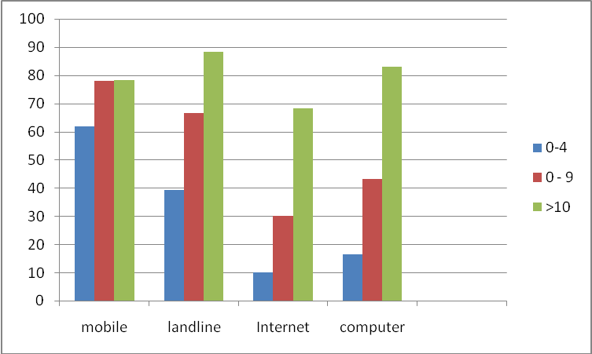

Figure 2: Penetration of Mobile, Landline, Internet and Computers among Palestinian Enterprises as Revealed by the 2009 Survey.
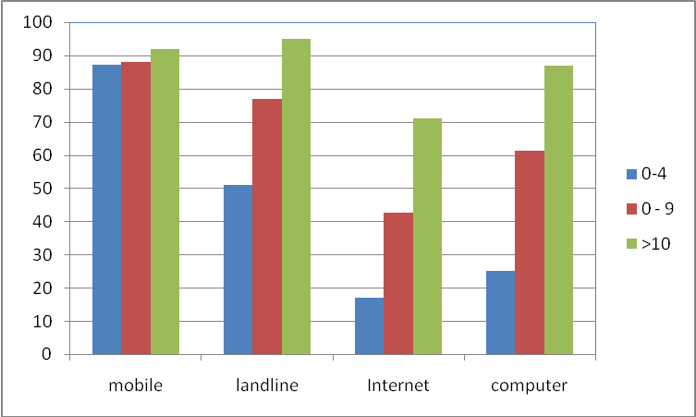

Figure 3: Comparison between Penetration Levels of Main ICT Indicators as Recorded by the 2007 and 2009 surveys.

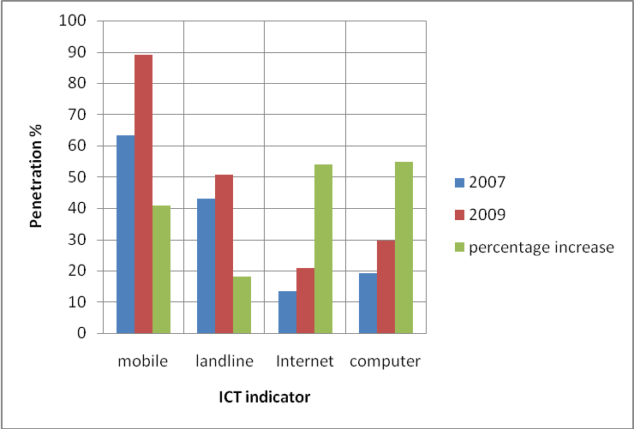

Figure 3 depicts the evolution of mobile penetration among Palestinian enterprises as recorded for the year 2007 and 2009, contrasted with other ICT indicators. Within two years (2007 to 2009), Mobile penetration recorded the highest growth rate among all indicators with a record of 26 points, whereas landline, Internet, and computers recorded 7.7, 7.3, and 10.5 points respectively. The increase in landline is referred to marketing campaigns, and the bundling of landline services with mobile and broadband Internet as the marketing manager of Paltel has revealed (Private communications). Remark that the Palestinian mobile operator (Jawwal) is owned by the Incumbent Paltel, which also provides besides landline broadband Internet services through ADSL.
The low penetration of fixed lines can be attributed to the reliance of enterprises on mobile phones which are used both for business and private purposes. Similar trend is reported in some African countries as described by E-Access Africa report published in 2006 (E-Access Africa 2006). Remark that the criterion to consider a mobile in the survey is that it is financed from enterprise budget.
It has been quite challenging to locate similar studies to contrast our statistics with, mainly mobile penetration by enterprises. Probably this is due to the fact that mobile is often associated with individuals not enterprises, and there is vague correspondence between mobile ownership and enterprise size, especially for large ones. Yet to have a notion on the level of mobile penetration in Palestine, we used per capita statistics, as was done by similar studies (Jagun et al., 2008; Chaharsooghi and Saneifard, 2009; Donner, 2006). Figure 4 categorizes Palestine within the group of countries in the Middle East for the three indicators shown. Palestinian records are comparable to the averages of developing countries, which renders valuable in contrasting our survey results with that of developing especially African countries.

Figure 4: Mobile, PC, and Internet Penetration Per Capita in Palestine as Contrasted to Some Countries in the Region. [Measuring the Information Society 2007, ITU]
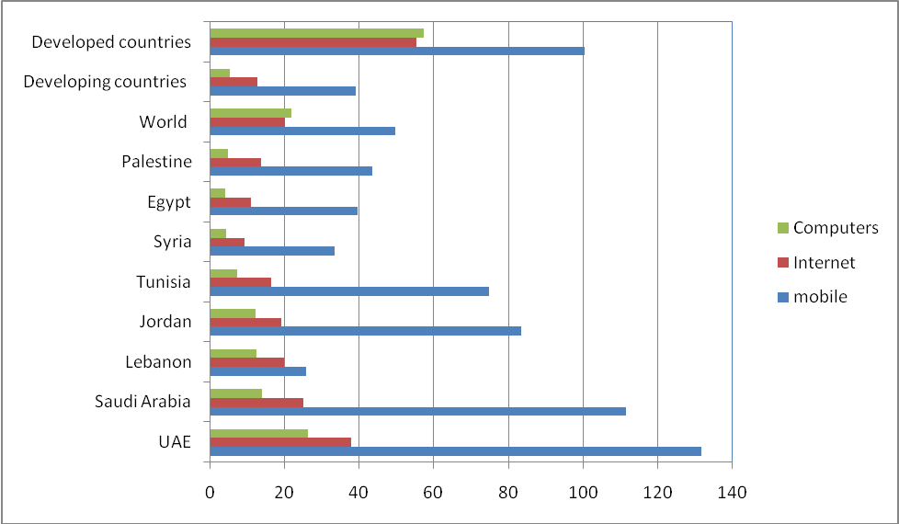

Table 3: Percentage of Enterprises by their Ownership of Mobile and or Fixed Phone Line, 2007

Ownership | Fixed Phone Line | Mobile Line | Percentage
Percentage of Enterprises without Fixed and with Mobile | No | Yes | 23.6
Percentage of Enterprises with Fixed Phone and without Mobile | Yes | No | 14.7
Percentage of Enterprises with Fixed Phone and Mobile | Yes | Yes | 54.4
Percentage of Enterprises Neither Fixed nor Mobile Phones | No | No | 7.3
Percentage of Enterprises with Either Mobile or Fixed Phone | No  Yes | Yes  No | 92.7

Table 3 justifies the modest penetration of mobiles amongst enterprises where some enterprises favor the use of fixed line to make their business calls. There are about 15% of all enterprises own a fixed phone and prefer not to use mobiles in their business. Figures shown in the last row of table (3) shows that 93% of all enterprises are keen to own at least one communication means. This might indicate that mobiles are purchased as substitute rather than complements to landlines, an observation recorded by other researchers in many developing countries, see (Donner, 2010).

5 The Use of Mobiles by Enterprises
This section was thoroughly prepared to investigate several issues in relation to mobile use by enterprises as stated by their owner and/or manager. The mobile use options were worked out in accordance to mainstream use of mobile as are reported in literature, recommended by experts or remarked by enterprise manager and owners during the trial survey. The typical applications investigated by the survey are described in figure 5.
It is essential to keep in mind that purposes of mobile use are highly interrelated. For example, information gathering does overlap with marketing, product delivery, and procurement. Also delivering products and providing customer services are also pretty mixed. As is shown in Figure 5,the vast majority of enterprises uses mobile to exchange information with stakeholders; mostly, producers, traders, wholesalers, retailer, and customers.

Figure 5: Typical Mobile Applications among Palestinian Enterprises

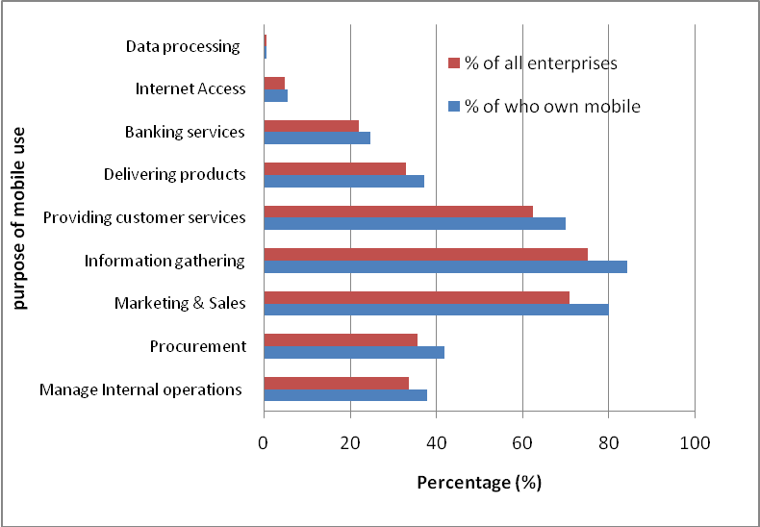

Of all enterprises 84% use mobiles for information related issues valuable for their businesses. This may indicate from one hand the deficiency in information these enterprises were experiencing prior to the introduction of mobile, and on the other hand the role of mobiles in opening a wide scope for information flows for these enterprises. This statement is in harmony with most literature reporting on the same subject; see (Donner, 2009). Second to information provision scope comes marketing and customer care services. 80% of all enterprises owning a mobile employed it in marketing activities, and 70% in customer service activities, equally recruiting new customers and providing after sales services. 37% of all enterprises reported on utilizing mobiles in delivering products for both retailers and customers. .
Using mobiles for banking services received a considerable attention by users and indorsed by about 25% of all mobile customers. Remark that the mobile banking investigated in the survey is the most basic type of mobile banking services, whereas, customers use their mobile to make phone calls to a bank officer for some information or services. Another form of mobile banking services uses SMS, in what is sometimes called SMS-based banking, where the customer receives short statements or text alerts that inform the customer of an activity on his/her account, such as deposits, withdrawals, and ATM or credit card use. More advanced types of mobile banking, where the customers can log into their account from a cell phone, and commit transactions using the mobile phone such as delivering payments, checking balance, and transferring money are still not available in the Palestinian market, and thus not covered by the survey.
Among the possible use of mobile by enterprises, is its use in managing internal operations within the enterprise. 38% of respondents used their mobiles some way or another to administrate their internal operations through managing their employees or coworkers, or manage inventories.
To have a broad idea on mobile use, advanced applications were incorporated into the survey; mainly information processing and Internet Access. Less than 1% of mobile users reported on their use of mobile phones for information processing, and less than 6% access the Internet via their mobiles. Remark that none of the Palestinian mobile operators are offering third generation services, which allow high speed Internet access into mobile, however, some people are using the 2.5 G, or GPRS to have a limited access to the Internet via their mobiles.

Figure 6: Mobile Use Contrasted with Computer and Internet Use by Enterprises as Recorded by the Survey

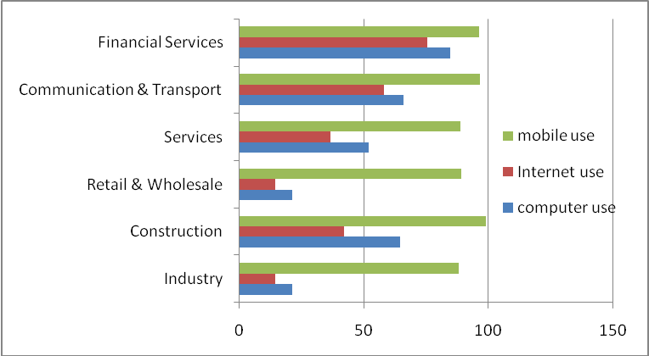

Figure 6 provides details on the penetration level of mobile phones among enterprises in comparison with that of Internet and computers grouped in accordance to their economic activities. Yet again mobile penetration is almost flat and close to 100% in all enterprises regardless of their economic activities.
The highest penetration is recorded in construction sector, and the lowest is in retail and wholesale. Remark that mobile recorded by the surveys are that used by employees and paid for by the enterprise, which might explain why some sectors like constructions, financial services, and communication and trasportation are almost perfect in their mobile use, ,since these firms are financially capable of paying for their mobile which is not always the case in other activities like retail and whole sale. On contrary, high variation did exist in computer and Internet penetration across different sectors, with the financial sector recorded the highest where 85% of all enterprises are using computers, and 76% are connected to the Internet. Wholesale and retails recorded the lowest with 20% uisng computers and 14% connected to the Internet.
The low take up of computers and the Internet in comparison with mobile can be reffered chiefly to financial constraints, lack of awarness of the potential benefit of these technologies, and shortage of competences to utilize these services. The same reasoning line is also reported by Information Economy Report (2008). Most of enterprises in retail and whole sale are micro, unofficial and family business enterprises, and mobile phones are affordable, easy to use and very effective in addressing their buisness needs. In contrast, computers and the Internet are highly endorsed by the financial, communication & trasportation, and the construction sector.

Table 4: Commonly Used Mobile Applications Categorized According to Economic Activity.

Mobile application: percentage of enterprises endorsed application | Industry | Construction | Retail & Wholesale | Service | Communication & Transport | Financial Services
Data Processing | 0.8 | 0.9 | 0.3 | 0.8 | 1.2 | 2.0
Marketing & Sales | 72.3 | 85.3 | 83.8 | 82.6 | 75.9 | 75.1
Information Gathering | 77.3 | 99.1 | 79 | 64.5 | 64.6 | 76.8
Banking | 26.1 | 37.7 | 22.4 | 18.6 | 25.2 | 54.8
Customer Services | 69.8 | 65.3 | 63.1 | 55.9 | 73.3 | 64.6
Product Delivery | 41.7 | 54.9 | 36.9 | 18.0 | 27.1 | 29.1
Internet Access | 2.3 | 2.5 | 4.5 | 8.0 | 4.8 | 11.2
Procurement | 52.3 | 55.5 | 32.8 | 43.9 | 42.1 | 56.7
Managing Internal Operations | 37.2 | 45.7 | 37.3 | 38.9 | 42.1 | 32.0

Table 4 provides details of the common purpose enterprises used the mobile for, as measured by the percentage of enterprises as categorized by their mainstream economic activity. As can be observed from that table, there is no significant variation among the sectors in relation to their use of mobiles. Most enterprises in the survey focus their mobile use primarily on operations related to sales, marketing, customer services, in addition to gathering and exchange of information. Construction, whole sales and service sectors use the mobile little more than other sectors as there deal with more suppliers and customers, both in the business-to-business and business-to-customer mode of operations. Our results in that regard are in agreement with a study done on enterprises in Ghana, which assessed that over 80% of SMEs used mobiles to make contacts between suppliers and customers (Frempong, 2009).

Figure 7: Percentage of Enterprises Endorsing Mobile Use Categorized According to their Sizes

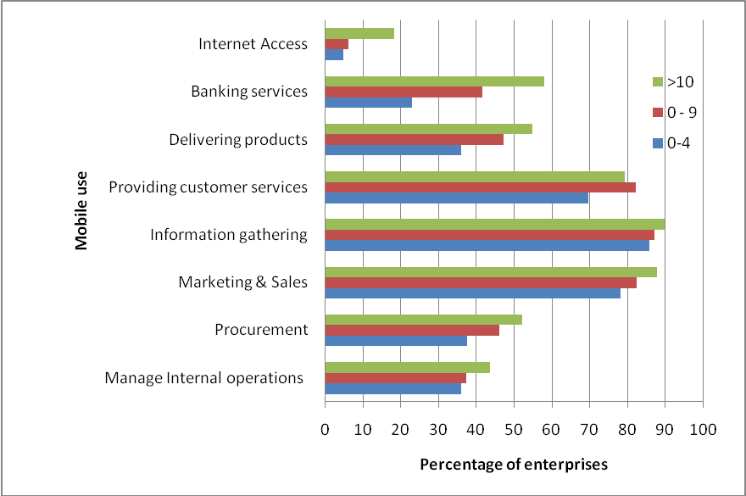

Figure 7 provides insight into the mobile purpose of use versus the enterprise size. As can be seen from the diagram in Figure 7 enterprise size has slight impact on the mobile purpose of use, especially in the main stream applications, such as information gathering, marketing, and customer service delivery. Visible differences in mobile use are witnessed in applications like procurement and product delivery, whereas substantial differences are recorded in banking and Internet Access again in accordance to enterprise size.
The majority of the enterprises were generally satisfied with the use of mobiles in their business; therefore it would be good to examine where the mobile has been most effective. To that end, enterprises owners and/or managers were asked to choose the most three perceived benefits mobiles have to their firms. The results are recorded in table 5.
Table 5 highlights some of the key perceived benefits selected by owners and managers of the enterprises. As can be seen from table 5, different sectors recorded comparable reactions in regards to perceived benefits.

Table 5: Perceived Benefits from Mobiles

Perceived Benefits from Mobile | Overall | Industry | Construction | Retail & Wholesale | Service | Comm.  & Transport | FinancialServices
Lower operational cost | 22.4 | 12.3 | 25.4 | 16.5 | 20.2 | 26.70 | 30.5
Improved products/ service quality | 24.3 | 14.3 | 16.7 | 20.5 | 26.7 | 27.50 | 35.8
Enhance response to customers | 84.4 | 76.5 | 81.6 | 83.2 | 88.1 | 90.30 | 81.9
Improved customer satisfaction | 62.4 | 67.4 | 50.6 | 60.4 | 62.9 | 67.00 | 78.8
Improved communication with suppliers & customers | 92.9 | 90.2 | 92.5 | 89.2 | 95.3 | 92.90 | 97.2
Keep up with competitors | 42.5 | 42 | 47.9 | 39.2 | 45.8 | 43.80 | 43.8
Bypass middle man | 16.4 | 12.8 | 20.5 | 17.1 | 14.4 | 13.80 | 12
Open up new business | 8.4 | 5.6 | 6.7 | 6.9 | 10.1 | 7.80 | 9.2

All sectors see mobile very valuable in enhancing communication with stakeholders, such that 84.4% feel enhancement in their response to customers. However, fewer (62%) reported on improved customer satisfaction. Other potential benefits like lowering operational cost, improvement of product and service quality, keeping up with competitors, and bypassing middle man, have received less emphasis by enterprises, see table 5.
Table 5 indicates that the financial service sector is gaining the most from mobiles, more than any other sector. This can be explained by the nature of its services and the reliance of its operations on communications, and its ability to tailor their services to be mobile enabled. In contrast, the sector benefiting the least from mobile is the industrial sector, and that is because manufacturing relies less on communication than other sectors.
It seems that the main impact of the mobile communication on the Palestinian enterprises stems from the communication power of the mobile phones, and the ability to use it to search and exchange information with stakeholders. This behavior impacts existing business operations rather than influences the way the business is structured through for instance bypassing the middle man or opening up new businesses. Remark that mobile is felt by only 8.4%, and 16.4% as a facilitator for opening up a new business, respectively bypassing the middle man, which is in agreement with most relevant literature, (Donner, 2010; Jagun et al. 2008).

6. Discussion
It seems that mobile phones are wining the hearts of people in the developing countries both in the business and non-business communities. And that is reflected on its unprecedented diffusion among societies and the enthusiasm in employing it in all facts of life including businesses. Features like, mobility, portability, immediacy, ease of use, and modularity of cost have made mobiles very attractive, especially in developing regions, where landline phones are not served. In addition of being a telephone, modern mobile devices can provide additional features; such as SMS messages, Internet access, gaming, Bluetooth, infrared, camera, MP3 player, radio and GPS, to name some. In the latest decade, researchers are pointing to mobile as the most influential technology in meeting the needs of individuals and enterprises, especially in the developing world. (Benkler, 2006; Castells et al., 2007).
In trying to better understand the impact of mobile on the Palestinian business sector we choose to employ Porter model of the enterprise value chain, which governs internal processes, and value system, depicting enterprise relations with other players like producers, traders, customers, and so on (Porter, 1998). The model was further extended by Duncombe & Heeks (2005) to fit MSMEs in developing countries. According to that model, enterprises in developing countries have communication needs arising from four different aspects: supply, demand, internal operations and operating environment.

Figure 8: Enterprise Value Chain (Duncombe & Heeks, 2005)

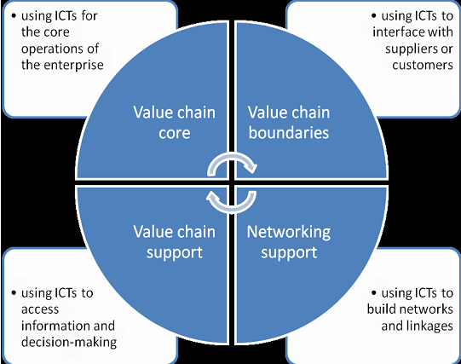

The value chain comprises all activities that an enterprise embarks on to add a value to a product or service as well as production processes, marketing, sales, procurement, human resources management, technology management, in addition to firm infrastructure.
Setting the stage to discuss the impact of mobile phones on enterprise value chain, and trying to categorize these into some groups, it is important to remark that the impact of technology might cross borders from one category into the other. As we shall see below, using the mobile phone to improve core value chain might also impact chain boundaries, and other value chain roles of enterprises. Some researchers used this argument in analyzing impact of mobile phones on enterprises, (Ilavarasan & Levy, 2010; Donner & Escobari, 2010).
As was shown earlier in the survey, many enterprise activities supported by mobile phones lie within the core of the value chain category, located in the upper left corner of figure 8. That includes making calls to manage internal operations (38%), marketing and sales (80.2%), providing customer services (70.2%), and delivering products (37.2%). Even gathering and exchange of information can lie within this category, as exchange of information is needed for both the supply and production sides. Many of the interviewed enterprises owners and managers reported that many of their phone calls are made to track employees and coworkers, money, inventory and supplies. The same trends can be inferred from table 5 which describes the perceived benefits from mobiles.
Several studies reported on similar benefits to core activities in the value chain resulting from mobile phone use. Donner and Escobari (2010) in their review article listed 10 research studies that confirm similar impact. These are Jensens (2007), Kamga (2006), Esselaar et al.(2007), Donner (2004, 2006, 2006a, 2007a).
Reaching out to suppliers and most importantly customers are among the most important gains reported by enterprises owners and managers, depicted in the upper right corner of figure 8. 92.9% of respondents of all enterprises of all economic sectors concur that mobiles improved communications with their suppliers and customers. Esselaar et al. (2007), reported on similar impact as he states “Mobile phones are used more often for keeping in contact with customers and clients. This is the highly visible, intuitive role of mobiles for small enterprises”. Jagun et al. (2008) explains how weavers use their mobiles to keep contact with their clients during production so they more effectively respond to their needs. Molony (2006) provided the example of Tanzanian traders and their clients in receiving feedback and building trust.
Another role for mobile is in supporting activities of the value chain. Mobiles are used to increase information flow between stakeholders of the value system. Of all respondents, information exchange recorded the highest score (84.8%) among all mobile activities recorded by the survey. information flow among actors was also reported by Donner and Escobari (2010) in their review study. They concluded that benefits from information dissemination were the most cited examples in studies from Abraham (2007), Adeoti & Adeoti (2008), Esselaar et al. (2007) Frempong (2009) Jagun et al. (2008), Jensen (2007) and Kamga (2006). Through the use of information, enterprise owners and managers were able to take the right decision at the right time, which reduced risks, increased profitability and allowed them to keep up with competitors (Jagun et al., 2008). In effect, perceived benefits from mobile phones as mentioned in table 5 can be attributed directly or indirectly to the increase in the flow of information in the chain system.

7. Conclusion
Mobile phones are highly attractive for use in business. Mobile phones are not only the most widespread technology among enterprises, but are being adopted at a faster rate than any other technology.
Though it has been around for less than 10 years; mobile phones are emerging as a powerful tool for optimizing internal operations and connecting enterprises with external players. This study showed that mobile phones are being used extensively by Palestinian enterprises mostly for voice conversation and text messaging.
As the study revealed, mobile phones are significantly affecting the internal processes of businesses, their value chain, and relations with customers and suppliers. Mobile phones have the potential to bridge the information gap and connectivity gap for businesses in developing countries.
Another significant conclusion the study draws is that small and micro enterprises are benefiting from the use of mobiles in the same as large enterprises, especially in marketing and customer service. This is happing at the time when there is a huge difference in resources between the two categories.
Yet other remarkable finding of the study is that mobile advantages are universal, and not favoring one business sector from the other. The study showed however a small variation in perceived benefits across economic sectors. Managers have been able to tailor use of mobile phones according to the needs of their businesses.
Finally it is critical to point out that this research looks at mobile impact on businesses in a unidirectional mode, that is to say, it tries to evaluate the potential positive advantages mobile phones might have on enterprises. However, that is only one side of the picture. Benefits from mobile phones are strongly dependent on how they are used and for what purposes. These issues can be further explored in future studies. Moreover, future research should address the possible correlation between use of mobile phones and productivity. Another interesting study would be to compare the impact of mobile phones with other ICT in businesses, which would help to understand the specific value-added contribution of mobile phones.

Acknowledgement

The funding of the Survey was provided by the Palestinian National Authority (PNA), and the Core Funding Group (CFG) for 2009. CFG members include the Representative Office of Norway to PNA; the Representative Office of Netherlands to PNA; the Swiss Agency for Development and Cooperation (SDC).

8. References
Abraham, R. (2007) Mobile Phones and Economic Development: Evidence from the Fishing Industry in India. Information Technologies and International Development 4, 1, 5-17.
Adeoti J.O. and Adeoti A.I. (2008) Easing the Burden of Fixed Telephone lines on Small-scale Entrepreneurs in Nigeria: GSM Lines to the Rescue. Telematics and Informatics 25, 1, 1-18.
African E-index (2006) SME e-Access and Usage across 14 African Countries, Research ICT Africa, South Africa.
Aker, J.C. (2008) Does Digital Divide or Provide? The Impact of Cell Phones on Grain Markets in Niger. Center for Global Development Working Paper 154.
Avgerou, C. (2006) The Link between ICT and Economic Growth in the Discourse of Development, in Korpela, M. Montealegre, R. & Poulymenakou, A. (Eds.), Proceedings of the International Federation of Information Processing, IFIP 9.4 and 8.2 Joint Conference on Organizational Information Systems in the context of Globalization (373-386) Dordrecht, The Netherlands: Kluwer.
Benkler, Y. (2006) The Wealth of Networks. New Haven: Yale University Press.
Boadi, R.A., Boateng, R., Hinson, R. and Opoku, R.A., (2008) Preliminary Insights into M-commerce Adoption in Ghana, Information Development, 23(4), 253-265
Castells, M., Fernández-Ardèvol, M., Qiu, J.L. and Sey, A. (2007) Mobile Communication and Society: A Global Perspective (Information Revolution and Global Politics) Cambridge, MA: MIT Press.
Chaharsooghi, S.K. and Saneifard, R. (2009) An Evaluation of Mobile Commerce Adoption in Iran, Journal of Computers, Vol. 20(2), 257-277.
David, P. (2000) Digital Technology and the Productivity Paradox: After Ten Years, What has been Learned? Mimeo, Stanford University, CA.
Donner, J. (2004) Microenterpreneurs and Mobiles: An Exploration of the Uses of Mobile Phones by Small Business Owners in Rwanda, Information Technology and International Development, 2, 1-21.
Donner, J. (2006) The Social and Economic Implications of Mobile Telephony in Rwanda: An Ownership / Access Typology, Knowledge, Technology, and Policy 19, 2, 17-28.
Donner, J. (2006) The Use of Mobile Phones by Microenterpreneurs in Kigali Rwanda: Changes to Social and Business Networks, Information Technology and International Development, 3, 3-19.
Donner, J. (2006a) The Social and Economic Implications of Mobile Telephony in Rwanda: An Ownership/Access Typology. Knowledge, Technology, and Policy 19, 2, 17-28.
Donner, J. (2007a) Customer Acquisition among Small and Informal Businesses in Urban India: Comparing Face to Face, Interpersonal, and Mediated Channels. Presented at Conference on Living the Information Society: The Impact of ICT on People, Work, and Communities in Asia, April, Manila.
Donner, J. & Escobari, M.X. (2010) A Review of Evidence on Mobile Use by Micro and Small Enterprises in Developing Countries. Journal of International Development, 22, 641-658.
Duncombe, R. & Heeks, R. (2005) Information & Communication Technologies (ICTs), Poverty Reduction and Micro, Small & Medium-scale Enterprises (MSMEs): A Framework for Understanding ICT Applications for MSMEs in Developing Countries. Vienna: United Nations Industrial Development Organization.
Esselaar, S., Stork, C., Ndiwalana, A. and Deen-Swarra, M. (2007) ICT Usage and its Impact on Profitability of SMEs in 13 African Countries, Information Technologies and International Development 4, 1, 87-100.
Frempong, G. (2009) Mobile Telephone Opportunities: The Case of Micro- and Small Enterprises in Ghana, Info 11, 2, 79-94.
Gordon, R. (2002) Technology and Economic Performance in the American Economy. Cambridge, MA: NBER working paper No. 8771.
Gregor, S., Fernandez, W., Holtham, D., Martin, S., Vitale, M. & Pratt, G. (2004) Achieving Value from ICT: Key Management Strategies, Department of Communications, Information Technology and the Arts, ICT Research Study, Canberra.
Heeks, R. (2002) Failure, Success and Improvisation of Information systems Projects in Developing countries. Manchester: IDPM, University of Manchester.
Hughes, N. and Lonie, S. (2007) M-PESA: Mobile Money for the Unbanked Turning Cell phones into 24-Hour Tellers in Kenya, Innovations: Technology, Governance, Globalization, 2, 1-2, 63-81.
Information Economy Report (2009) Trends and Outlook in Turbulent Times, United Nations Publications, UNCTAD/IER/2009, Geneva, Switzerland.
International Finance Corporation (IFC) (2007) Microfinance Market Survey in the West Bank and the Gaza Strip. PlaNet Finance. Washington D.C.
Jagun, A., Heeks, R. and Whalley, J. (2008) The Impact of Mobile Telephony on Developing Country Micro-Enterprise: A Nigerian Case Study, Information Technologies and International Development, 4, 4, 47-65.
Jensen, R. (2007) The Digital Provide: Information (Technology), Market Performance, and Welfare in the South Indian Fisheries Sector, Quarterly Journal of Economics, 122, 3, 879-924.
Kamga, O. (2006) Mobile Phone in Cote d'Ivoire: Uses and Self-Fulfillment, Presented at the International Conference on Information and Communication Technologies and Development, 25-26 May, Berkeley, CA.
Kenny, C. (2006) Overselling the Web: Development and the Internet, Boulder: Lynne Rienner.
Koellinger, P. (2006) Impact of ICT on Corporate Performance, Productivity and Employment Dynamics, Special Report No 01/2006, European Commission Enterprise & Industry Directorate General, Berlin.
Krishna, S. and Madon, S. (2005) The Digital Challenge: Information Technology in the Development Context, Ashgate Publishing Ltd.
Love, E.D., Irani, Z. and Edwards, D.J. (2004) Industry-centric Benchmarking of Information Technology Benefits, Costs and Risks for Small-to-Medium Sized Enterprises in Construction, Automation in Construction, 13, 4, 507-524.
Lucchetti, R. and Sterlacchini, A. (2004) The Adoption of UCT among SMEs: Evidence from an Italian Survey, Small Business Economics, 23, 2, 151-168.
Molony, T. (2008) The Role of Mobile Phones in Tanzania’s Informal Construction Sector: The Case of Dar es Salaam, Urban Forum 19, 2, 175-186.
Morikawa, M. (2004) Information Technology and the Performance of Japanese SMEs, Small Business Economics 23, 3, 171-177.
Overå, R. (2006) Networks, Distance, and Trust: Telecommunications Development and Changing Trading Practices in Ghana, World Development 34, 7, 1301-1315.
Palestine in Figures 2007. Palestinian Central Bureau of Statistics, 2008, Ramallah – Palestine.
Porter, M.E. (1998) Comparative Advantage: Creating and Sustaining Superior Performance. New York: Free Press.
Roman, R. (2003) Diffusion of Innovations as a Theoretical Framework for Telecenters, Information Technologies and International Development, 1, 2, 53-66.
Schreyer, P. (2000) The Contribution of Information and Communications Technology to Output Growth: A Study of the G7 Countries. Paris: OECD, STI working paper DSTI/DOC.
Schubert, P. and Leimstoll, U. (2007) Importance and Use of Information Technology in Small and Medium-Sized Companies, Electronic Markets, 17, 1, 38-55.
Schubert, P. and Leimstoll, U. (2006) The Importance of ICT: An Empirical Study in Swiss SMEs, 19th Bled Conference eValues, Bled, Slovenia, June 5-7.
Stiroh, K. (2002) Are ICT Spillovers Driving the New Economy? Review of Income and Wealth, 48, 1, 33-57.
Unwin, T. (2008) General Editor, ICT4D: Information and Communication Technology for Development, Cambridge Press.
Vigneswara, I.P. and Levy, M.R. (2010) ICTs and Urban Microenterprises: Identifying and Maximizing Opportunities for Economic Development, Canada's International Development Research Centre (IDRC), Canada.
Walsham, G. and Sahay S. (2006) Research on Information Systems in Developing Countries: Current Landscape and Future Prospects, Information Technology For Development, 12, 7-24.
Waverman, L. Meschi, M. and Fuss, M. (2205) The Impact of Telecoms on Economic Growth in Developing Countries. In Africa: The Impact of Mobile Phones, ed. Vodafone, Vodafone Policy paper No. 2, 10-23.

