Economic and Social Empowerment of Women through Information and Communication Technology: A Case Study of Palestine

ABSTRACT
This paper presents an insight into an initiative that intends to empower women through Information and Communication Technologies, by means of a joint venture between NGOs and local women organizations. The paper reflects on direct and indirect impacts of the initiative that targeted hundreds of women in Palestinian rural areas. The research team tracked the trainees' responses and the evolution of their capabilities through qualitative and quantitative means such as focus group discussions, interviews with stakeholders, questionnaires, surveys, and observations of on-going activities.
The initiative exerted considerable efforts to enhance ICT technical capabilities of women, develop their entrepreneurial capabilities, and in other ways promote social and economic empowerment. A significant percentage of the surveyed women felt that they gained some level of empowerment and self confidence through mastering the basic ICT competences, and believed that ICT is helpful in improving their livelihood. However, there was little evidence of the transformative potential of ICT that is sought out of such initiatives. The project had some impact on the women’s personalities, on the way they perceive themselves in their families and societies.
However there are vital issues demanding further attention. Key amongst these is improving the ability of women to utilize ICT effectively and in particular for knowledge attainment and creation, in personal and community development, and as a socialization channel.

KEYWORDS
Women and ICT, women empowerment, ICT in rural area, ICT for development
- INTRODUCTION
Development circles such as the World Bank, the United Nation Development Program-UNDP, and United Nations Development Fund for Women-UNIFEM believe that ICT symbolizes an exceptional enabling instrument when deployed and used properly. According to Abbasi (2001), ICT represents a unique “knowledge-based social Infrastructure” which can be of great help for women to evade marginalization. Ningo (1999) argued that development cannot be achieved though ICT without taking gender issues into consideration. ICT can work as a novel opportunity to enhance women’s access to information and knowledge, as women are the least educated and marginalized, especially in developing countries, Sharma (2001).
Several reports have discussed opportunities for gender empowerment through ICT, e. g. through education and knowledge creation, poverty alleviation, and employment generation. Among them are Mitter & Rowbotham (1995), Huyer (1997), Rathgeber and Adera (2000), Hafkin (2000), Marcelle (2000), Munyua (2000), Opoku-Mensah (2000). As a sign of importance, in 2001 the International Development Research Centre - IDRC published what can be regarded as a reference for gender and ICT, Rathgeber and Adera ( 2000). Hafkin (2000) published a review of the “gender and ICT” theme, and provided a historical perspective of how ICT, development and gender have emerged. Other key issues related to the subject were raised by Obijiofor (1998), such as; does ICT promote interaction of women within the society and open up new channels which allow women to discuss openly issues that are considered “taboo” using classical means, especially in traditional societies. The study of Rathgeber (2000) emphasized the need for national information-technology policies that take into consideration the attitudes and needs of female users, as it takes that of males.
However, the majority of women in the developing countries, as Odedra and Stroub (1995), and Huyer (1997) have argued, are living in economic and social hardships that act to hinder these technologies from being utilized. Additionally, the high degree of illiteracy inhibits use of ICT. Women in developing societies, including Palestine lack financial resources to purchase hardware, software, and to connect to the Internet. They also lack sufficient computer education and training facilities to develop the needed competences to seize the opportunities opened up by ICT. Therefore, step number one would be to open up doors of access for women to ICT with user friendly systems and relevant indigenous content. One channel to achieve these goals, as Huyer (1997) noted, is via training centers that are built in cooperation with local institutions to which women have equal and open access, such as community, women and youth centers, clubs, public libraries, schools, and universities. This article discusses an initiative that provides access to ICT through community and women centers that are located in remote and rural Palestinian areas.
As has been argued by many specialists, accessing ICT resources does not guarantee attaining empowerment and development, there still exists the lack of suitable approach and indigenous content, through which women can work to improve their conditions (Unwin 2008). The type of information being accessed, especially whether it is locally relevant, is central to the effectiveness and success of such initiatives. In most ICT projects, attention to technology implementation overwhelms contents presentation and acquirement of knowledge. The paper sheds light on this side of the initiative and examines how successful it has been in that regard. Yet if access, skills, technology and content are properly taken care of, the barrier of culture can still act to spoil the preset goals and potential of such initiative. Cultural issues are overlooked by most planners, and this paper explores how these affect women’s abilities to benefit from such initiatives. The extent to which cultural issues have been taken into account is one of the issues that will be investigated.
To place the reader within the context of the project setting, a description of women status within the Palestinian society is given below. In Palestine, several organizations are working towards improving the position of women in the society and addressing gender and equality issues. The most recognized are the General Union of Palestinian Women, Ministry of Women Affairs, Women’s Affairs Technical Committee, Women’s Center for Legal Aid and Counseling, Women’s Studies Center, Palestinian Working Women’s Society, and the UNIFEM. These organizations are exerting efforts towards empowering women through initiatives in livelihood, education, health, and recently in ICT. Palestinian women are enjoying an advanced position in the society in comparison to other developing and Arab countries. The school enrolment rate among Palestinian children is about 99% and 50% are female. The 2008 illiteracy rate is recorded at 5.9 %, 9.1% among women and 2.9% among men. However, in the workforce, women make up less than 15% of the salaried employees. Table (1) gives an overview of women’s status in the Palestinian society in 2008, as measured by the Palestinian Women Research and Development Center (PWRDC), as of 2008.
Table (1): Palestinian Women status as of 2008 [PWRDC, 2008]
Female employment rate | 14.7%
Female Palestinian legislative Council members | 12.9%
Female judges | 11.2%
Female prosecutors | 12.1%
Female doctors | 12.1%
Female lawyers | 11.2%
Life expectancy | 74.4 years
Female literacy rate | 90.9%
Female youth literacy | 98.8%
Female school attendees | 50%
Female university attendees | 50%
This study analyzes the endeavors of two organizations that are active in women’s empowerment through various means, including ICT. Relief International Schools on line, (RI-SOL) (http://www.ri.org/), and United Nations Development Fund for Women UNIFEM offer training programs in basic ICT for thousands of Palestinian women, especially in rural and remote areas, with the following goals in mind:
- Train women with the vital living skills in order for them to take a dynamic role in their societies through integrating ICT into all aspects of life;
- Empower women through ICT training on legal issues, non-violence, political participation and civic education;
- Organize activities that support educational, economic and political development;
This paper summarizes the results of an evaluation initiative primarily designed to investigate the relevance of current training to the needs of rural women and their communities in the view of the preset goals. UNIFEM has a broad initiative for women in development called Sabaya (Arabic word for youthful women) (http://www.sabaya.org/english.php). Through this initiative, the ICT for Women Development Program was implemented in the Palestinian territories in 2004 in partnership with the United Nations Development Program/Program of Assistance to the Palestinian People (UNDP/PAPP) with funding from the Government of Japan. The Sabaya initiative aims to implement and operate women‘s centers with a wide range of activities in rural communities. UNIFEM has completed the first and second pilot phases of the Sabaya program in nine rural communities in the West Bank. Since the pilot phase, the program has been expanded to cover a total of 18 rural communities in the West Bank and Gaza Strip. With additional funding from the Government of Norway, the Sabaya program has also benefited from targeted humanitarian assistance for Palestinian women. A minimum of 600 women are trained, including in basic ICT skills, at these centers annually.
Since 2004, RI-SOL and UNIFEM have provided training programs in basic ICT skills for thousands of rural Palestinian women. Motivations for this training are diverse, including increased demand for employees with ICT skills, the desire for rural women to help their children with homework and the necessity of accessing knowledge and communicate through the Internet. This paper presents an assessment of the project and evaluates its level of success, as viewed by the various stakeholders, with emphasis on the relevance of current training to the needs of rural women and their communities, and the ways in which their relevance can be enhanced.
2. RESEARCH METHODOLOGY
Details of the research methodology adopted in this research were described elsewhere, Rabayah, (2008). To ensure credible results, blended techniques, both quantitative and qualitative were employed. Reviews of current training materials, user feedback through questionnaires and focus group discussions were among techniques used. Views of trainers, course administrators and target group representatives were collected and analyzed [ibid]. As has been discussed in [ibid], data collected via quantitative methods were contrasted and validated through focus group discussion, and trainers’ interviews. A total number of 118 female members participated in the surveys at seven locations in the West Bank. 60 women took part in the focus group discussions, which consisted of four groups of 15 women each.

Furthermore, to get a clearer picture of the women’s perception towards ICT training and their expectations, six additional semi-structured focus group discussions were convened. By holding these focused discussions, it was possible to effectively assess perceived relevance of training courses to the everyday lives of rural women and the development needs of their communities. It has been noted that responses given to questions regarding course expectations and reasons for undertaking training courses can alter due to the changed perceptions developing throughout the training course itself. Therefore in order to get an accurate picture as to why rural women feel the need for ICT training and what expectations they have of that training, six additional semi-structured focus group discussions were held with a total of 104 rural women.
However, and as discussed in [ibid], collected data were disaggregated according to age and profession. The only significant age-related difference worth noting is that older women were less aware of impact of these technologies on the economic and social status of women. The differences were more pronounced when the level of education and job occupation is considered, especially as to the reason why women were seeking ICT training. More on this will follow in the subsequent sections.
3. RESULTS ANALYSIS
The key issues to be analyzed in this section is categorized into four issues; course materials, rationale behind rural women seeking ICT training, perception of rural women towards ICT training courses, and finally immediate and long term impact of ICT training on women.
The first two issues were extensively discussed in Rabayah (2008). In order to complete the picture of the training initiative, we introduce a summary of the main results of these findings as presented in [ibid]. In regards to training material, the International Computer Driving Licence (ICDL)-based standard, composed of basic skills in Windows, Office and the Internet, was used. This arrangement was considered a major defect since other ICT resources like mobile phones, radio and TV, were not given any attention, though they can have significant impact on women’s development [ibid]. Another shortcoming was the focus on technical skills on how to use computers, with less emphasis on how to leverage knowledge and boost empowerment among trainees. In such a venue, mastering the basic ICT skills was seen as an end in itself and not as a vehicle to sensibly improve the lives of rural women and their communities. Even trainers revealed that leveraging knowledge and economic and social empowerment were not directly targeted, and they themselves were not prepared to coach women in that direction. Furthermore, training materials were not effective in achieving such goals, as communicated by the majority of trainers [ibid].

3.1 Motivation behind seeking ICT training
In regards to why do rural women seek ICT training, the majority of women aspire to attain basic ICT skills to enhance the quality of their lives in terms of knowledge or for employment purposes. A considerable percentage (32%) sought to increase the level of their knowledge and awareness through ICT. The next most common rationale, 22%, was to enhance their employment position and earning power, while 19% did the course primarily to help their children to learn ICT, see figure 1 [ibid]. Analysis of the results showed that students and unemployed women recognized the importance of ICT in terms of access to knowledge and increased employment prospects. What seems to be missing was an understanding of ICT as a tool for social empowerment and community development, or what is recently coined as networking and socialization side [ibid].

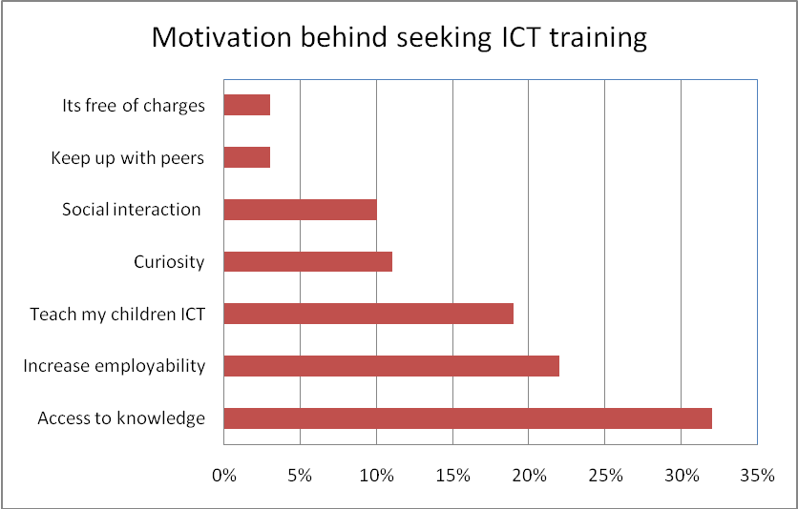

Figure 1: Recorded women’s reactions in regards to their motivation towards the ICT raining [ibid]

Only 10% of participants saw the training as a window for socializing with others and 3% saw it as a way to keep up with their peers. These aspects are not directly linked to original objectives of the training. Such reactions illustrate that social dimensions, both in families and communities are important for some women besides access to knowledge and increasing employability [ibid].
3.2 Perception of ICT training by rural women
The survey offers a positive and encouraging overall view of the ICT training initiatives. In fact over 80% of the women who participated in the training felt it had been on the whole useful. A similar percentage was keen to enroll in future courses in order to further improve their skills. However, it is important to look at women's perceptions of outcomes and impacts in depth in order to ascertain whether these types of initiatives really make a difference to women's lives, and the development of their communities and if not, how they can be improved to contribute to impacts in these areas in the future. In order to conduct this in depth review, we shall explore women’s perceptions in the context of "empowerment" in terms of access to knowledge, social empowerment, and economic empowerment.
Empowerment entails acquiring knowledge, fostering self confidence, expansion of choices, participation in decision making and improving access to and control over resources, Stromquist (2005). ICT, when used effectively, can achieve all of these goals. Access to resources is indeed the key, with knowledge being the most important resource of all. ICT is able to improve women's standing both economically in terms of access to greater opportunities and higher wages and socially in terms of networking and social interaction. While "political empowerment" will not be discussed in depth as part of this study, it is implicitly sought throughout the initiative. For instance, as women are able to increase their knowledge and connections with others, gain status within their social sphere and increase their earning power, they will eventually have more capacity to contribute in and lead political movements. Through the following sections we shall see if the initiatives have contributed to empowerment, how this impact can be improved, and whether such gains were utilized for the overall development of the surrounding communities.
3.3 Access to Knowledge
The importance of knowledge and the ability of ICT to improve access to knowledge for work and education, seemed, to be well known by the female students and labor force participants who have undertaken the ICT training courses. As noted earlier, access to knowledge was the primary reason, cited by 32% of women. However, it was noted that this was conceived by women as knowledge for work or (formal) education and not for community development or empowerment. With this in mind, it is positive to see that overall, participation in ICT training courses has seemingly opened up doors for women to learn and expand their knowledge horizons. In fact 80% of women, covering all age and occupational status groups stated that following these ICT courses, they wished to explore other learning opportunities. However, when it comes to the actual practical usage of ICT, and in particular the Internet as a tool for accessing knowledge, the current ICT training courses were perceived as less successful. Although the use of the Internet was a key course component in the program, 46% of women were not satisfied with the level of Internet skills gained from the training. Moreover, as shown in figure 2, 52% of women did not feel that the training had equipped them with the skills to use Internet as a tool to improve their knowledge.
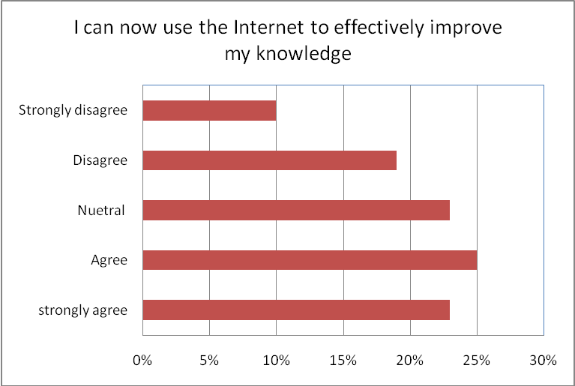
Figure 2: Effectiveness of the Internet in knowledge acquisition as recorded by participant women
In support of this finding, information revealed by trainers showed that, while some women were aware of the prospective benefits of the Internet in regards to knowledge, accessing the Internet seeking knowledge was limited to purposes of work or studies. For women who were neither student nor in the work-force, trainers noted that their practical usage of the internet was revolving around its use as a communication tool. Focus groups, while revealing the same results, shed more light on the reasons behind this. As recorded by the survey, while 60% of rural women have access to computers, only 25% have regular access to the Internet, the result being that, in the words of one respondent "I use the Internet to talk to family members and friends who live elsewhere. I don't have time to look for information on this or that." Such comments show the need for improved access to the Internet for rural women and also for trainers to work in changing perceptions of the use of Internet as a tool for knowledge. The benefits of doing so can also be seen in focus group discussions. For the minority of women who felt that the training had strongly improved their ability to gain knowledge via ICT, numerous benefits were felt to be present. For example, one respondent believed that, "I now have better awareness regarding information on health, women rights and educational opportunities. I have been able to find out many things that I did not know before and now, whenever I need to know anything, I feel confident I am able to easily find an answer, thanks to the Internet." Such comments show that when used effectively, the Internet can have an eminent impact on the lives and spirits of rural women. It therefore rests on trainers and the design of ICT courses to show that accessing knowledge should not be seen as a frivolous activity or something only useful for work or study, but as something that can have a large positive impact on both individual women's lives and their communities too.
3.4 Economic Empowerment
Increased employability was the second most cited rationale for rural women attending ICT training courses. 22% of women, (mainly students and labor-force participants), stated this as their main incentive. ICT was seen by women as an enabler to increase their economic empowerment in terms of earning power and position. This is mainly seen in terms of additional social status and increased participation in decision making. As such, results recorded here will also have an impact on levels of social and hence political empowerment. At a general level it is encouraging to note that 91% of women, cutting across the range of age groups and occupational status surveyed reported a perceived positive impact on their likelihood to be able to find work, see figure 3 and figure 4. In particular, according to focus group discussions, many women felt that they had improved their communication and interpersonal skills. This is important to note as many women who are not currently employed felt that they had benefited in terms of employability although they did not set out with this aim in mind. Formal certification was requested by 91% of women according to survey results. As certificates were also requested by women who were not in the work-place, this may indicate that for many women the training was seen as a potential chance to access employment opportunities in the future.
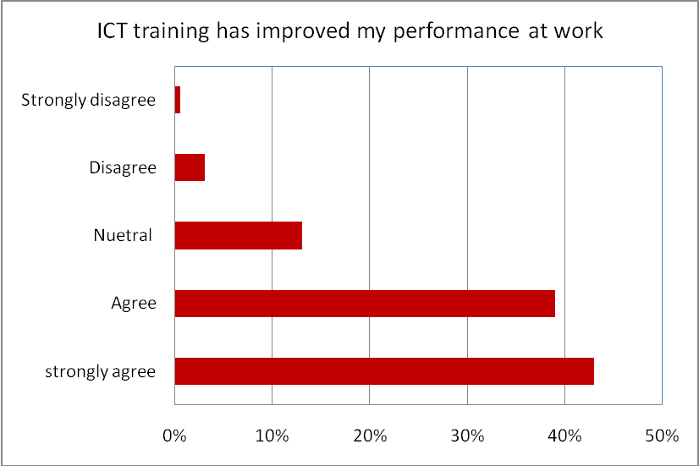
Figure 3: Impact of the ICT training of the employed women on their work When looking specifically at the 13% of survey respondents who were in employment, 83% of them either "strongly" or "very strongly" agreed that the ICT training courses had improved their work performance. Focus groups also revealed that this effect was most evident for staff members working for rural women’s organizations, perhaps due to the fact that ICT is a competence lacking in many of these organizations when the survey was undertaken. In addition a minority of women reported improved confidence in the workplace due to the increase in skills attained through these courses. For example, one woman working as a local council leader stated, “I used to be timid, and although I was already in the council I used not to contribute effectively in the council activities. With the training, I can now participate and contribute more in my work and feel that I can express my view without hesitation”. Thus it can be seen that the majority of women, whether or not they were in the paid workforce, perceived a positive impact in terms of ability to gain economic empowerment. However it was also shown in focus groups that none of the women perceived that such skills could help them either specifically in starting their own income generating initiatives or economic initiatives which may benefit their community. Again this is an area on which a greater focus is needed to enable women to become aware and then to act upon such opportunities.
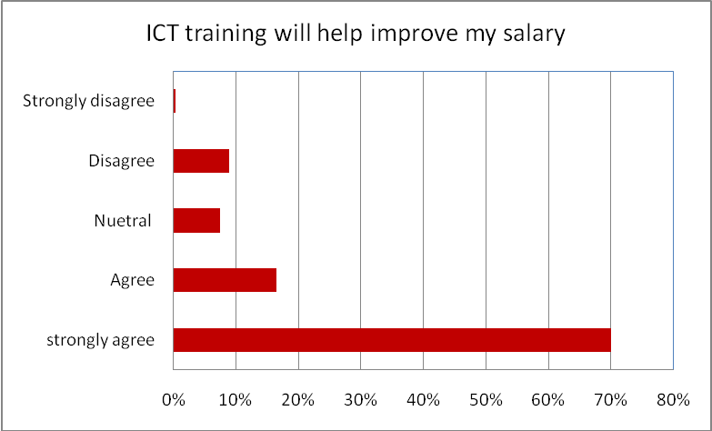
Figure 4: Expected impact if the ICT training on the women income
3.5 Social Empowerment
Self confidence was not given as a motive to pursue ICT training by any of the women participating in this survey. However an increase in self-confidence can be seen to be one of the most important impacts stretching across age groups and occupational status. Increase in self-confidence can help women to be aware of their own skills and competencies and hence make them more likely to struggle against social norms and barriers associated with gender. It is thus very important to see that one of the major positive perceptions of the ICT training courses has been an improvement in this aspect. As shown in figure 5, 96% of rural women "strongly" or "very strongly" agreed with the statement that their self-confidence had been improved by ICT training. In fact, no respondents were recorded as disagreeing, showing that this was a key area of overall success for current ICT training courses. This strong sentiment was also supported by focus group findings. Many felt that, "the training course has given us the chance to prove ourselves and our abilities to be modern, open minded, and to understand many of the ICT tools that used to be mysterious for us as women. This gave us the chance to prove that we can catch up with something that used to be dominated by men.”
As the above comment shows, it seems that this reported increase in self-confidence stems from the fact that through this training, women have realized that they can achieve things that perhaps others felt unattainable. This is particularly the case for older participants, as it seems society in general underestimates the ability of older women to adapt to new technologies. This was, as shown earlier, even found to be case for some trainers, who expressed surprise at the ability of older women to learn ICT skills. As one trainer commented, "Recently I met one of the old women who I had trained and she expressed genuine gratefulness for enabling her to talk to her son, who is abroad, via the internet. I was really surprised - it really showed me how worthwhile the course is - something I had not realized before."
Through undertaking such courses women are able to prove to themselves and to others that they are just as capable as their male counterparts when given the same opportunities. As one trainee, aged 58 stated, “Throughout the course we had the opportunity to strengthen our internal sense of our own competencies and to prove that we can still gain knowledge and experience in one of the most important aspects of the modern history”. It is also interesting that this is the only area in which there was an age differential in terms of responses given by rural women. This also supports the fact that age is not the main determinant in ICT ability and as such age should not be a key factor driving the development of curricula to improve the ICT skills of rural women.
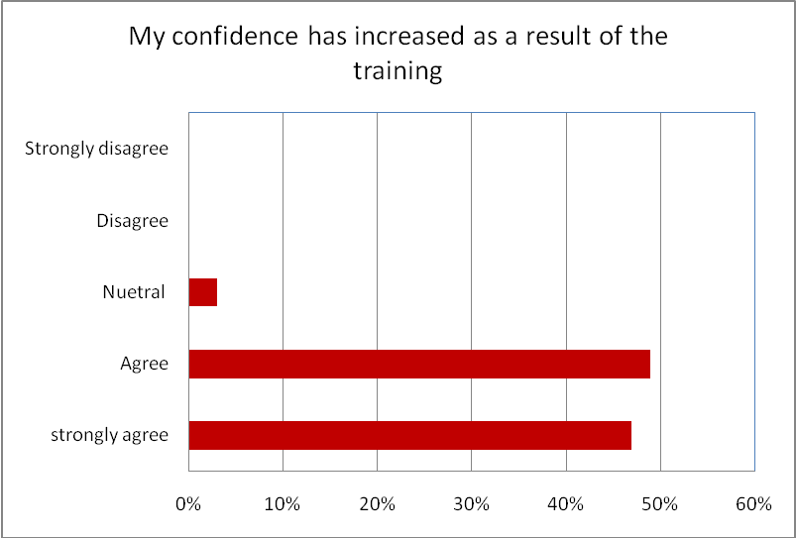
Figure 5: Recorded women’s reactions in regards to the impact of the ICT training on their self-confidence
In addition to this increased self-confidence, many women have reported expansion in their relations with others. This is an encouraging sign, given that only a small proportion of women sought ICT training in order to improve their social connections. According to focus group discussions, many rural women have seen this initiative as a good opportunity to establish connections and be more social - simply socializing outside of the house was a major benefit in some cases, where women face social barriers to participating in activities outside their houses or villages. In addition to this, and perhaps as a result of increased self-confidence and skills, many women recorded that they had noticed changes in the perceptions of them in the eyes of others. As shown in figure 6 and 7 below, over half of women surveyed felt that they had gained status as a result of participating in the initiative. Moreover this improved status was felt to be both in terms of the work-place, where 56% of women perceived an improvement in their status among colleagues, and at home where again 56% of women perceived an increase in their status within the family. Such improvements in status show the vital wider impact that ICT training courses can have on the lives of rural women.
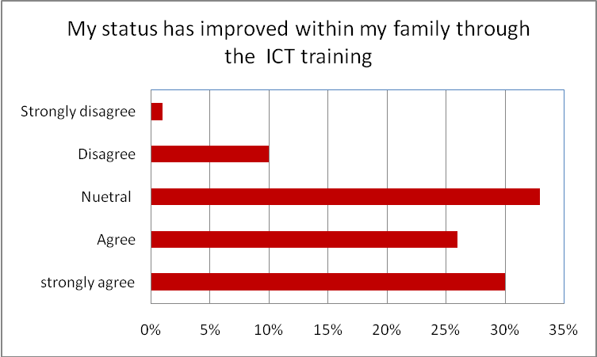
Figure 6: Recorded women’s reactions in regards to the impact of the ICT training on their image among their families
As can be seen from the discussion above, ICT can be an effective empowering tool, able to impart a valuable influence on the lives of rural women. In some areas, the present initiative is achieving some of these goals. Women feel that due to ICT training, they have better employment options and have usefully enhanced their competencies. They felt encouraged to undertake new training courses and considered that their status amongst colleagues and families has been improved. Moreover, the self-perception of women has been positively impacted, with women feeling they can now achieve things, which others may not have thought possible. Such positive effects are vital to the overall success of these training initiatives.
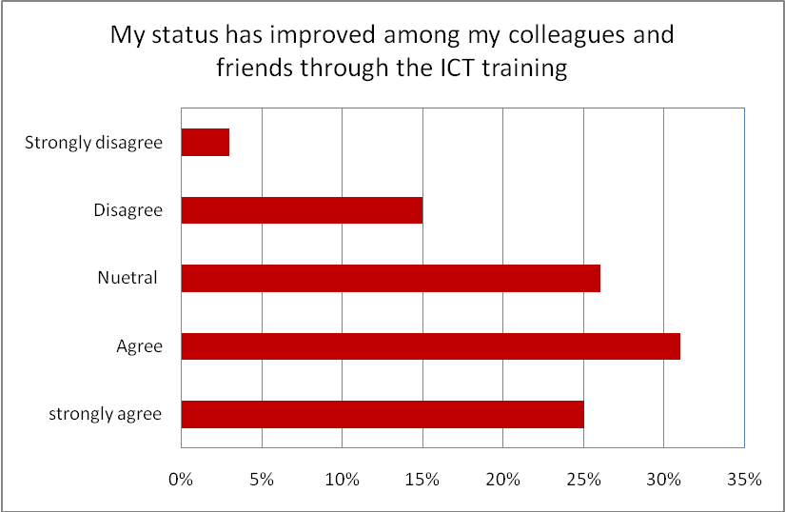
Figure 7: Recorded women’s reactions in regards to the impact of the ICT training on their image among their colleagues
4. CONCLUSION
The overall impact of ICT on women’s position as revealed through this research as reflected in intended and unintended outcomes, is to some extent positive and heartening. The study demonstrated that the majority of participants seek to obtain ICT training with the intention to enhance the quality of their lives through acquiring knowledge, enhancing their employment position and earning power, or enhancing their employment opportunities. The analysis has revealed that the majority of women, whether in employment or not, did perceive a positive impact in terms of ability to gain economic empowerment. What seems to be missing is the use of ICT as a tool for societal and community development, and to some extent as networking and socialization means.
On the personal level, an increase in self-confidence, sensed by most women regardless of their age or occupational status, has emerged as a significant unintended outcome of the initiative. 96% of rural women either "strongly" or "very strongly" felt that their self-confidence had improved due to the initiative. The development of this sentiment by women restored their awareness in their capabilities and competencies and hence made them more determined to struggle against social norms and barriers associated with gender.
One pitfall of the initiative was that mastering the basic ICT skills were seen as the end goal and not as an instrument to sensibly improve the lives of rural women and their communities. 52% of women did not feel that training had equipped them with the skills to use Internet as a tool to improve their knowledge. It therefore rests on trainers and those who design ICT courses to show that accessing knowledge should not be seen as a trivial activity or something only useful for work or study, but as something that can have a large positive impact on both individual women's lives and their communities. But this is not sufficient. In order for ICT to contribute to the lives of women in this way, rural women also require improved access to the Internet. The minority of women who felt that the training had strongly improved their ability to gain knowledge via ICT had benefited in several ways from access to its information and communication capabilities.
ACKNOWLEDGMENT
Sincere thanks are extended to the UNIFEM organization, Palestine, and the Relief International Schools on Line, for their provision of the necessary resources to accomplish the work. Suad Abu-Kamleh, from UNIFEM, Jawad Abu Own, Davina Jeffery, and Naser Arda, from RI-SOL, and Ola Sbehat, from the Arab American University, contributed significantly and without their help, this work would never have been completed.
REFERENCES
Abbasi, Z. F. (2001). Pro-Poor and Gender Sensitive Information Technology: Policy and Practice.’ Electronic Publication, http://www.comminit.com/st2002/sld-6845.html
Hafkin, N. J. (2000). Convergence of Concepts: Gender and ICTs in Africa. In E. M. Rathgeber and E. O. Adera (eds.) (2000) Gender and the Information Revolution in Africa. Ottawa: International Development Research Centre (IDRC), Chapter 1. http://www.idrc.ca/books/focus/903/04-chp01.html
Huyer, S. (1997). Supporting Women’s Use of Information Technologies for Sustainable Development. IDRC, http://www.idrc.ca/acacia/outputs/womenicts.html
Marcelle, G. (2000). ICTs & development — making it happen. In D. Lush & H. Rushwaya (eds.) (2000) Into or Out of the Digital Divide: Perspectives on ICTs and Development in Southern Africa. Panos Southern Africa. http://www.panos.org.zm/marcelle.htm
Mitter, S. & Rowbotham S. (1995). Women Encounter Technology: Changing Pattern of Employment in the Third World. London and NewYourk: Routledge. http://www.unu.edu/unupress/unupbooks/uu37we/uu37we00.htm#Contents
Munyua, H. (2000). Application of ICTs in Africa's Agricultural Sector: A Gender Perspective. In E. M. Rathgeber and E. O. Adera (eds.) (2000) Gender and the Information Revolution in Africa. Ottawa: International Development Research Centre (IDRC), Chapter 4. http://www.idrc.ca/books/focus/903/07-chp04.html
Ningo, N. (1999). ICT and Sustainable Good Governance in Sub-Saharan Africa: Countering the Hegemonic Drive for Power. Washington DC: World Bank, http://www.worldbank.org/
Obijiofor, L. (1998). Future of Communication in Africa's Development. Futures, 30(2/3), 161-174
Odedra-Straub, M. (1995). Women and Information Technology in Sub-Saharan Africa: A Topic for Discussion. In S. Mitter and S. Rowbotham (eds.) (1995) Women Encounter Technology: Changing Patterns of Employment in the Third World. London: Routledge, pp. 256-277
Opoku-Mensah, A. (2000). ICTs as Tools of Democratization: African Women Speak Out. In E. M. Rathgeber and E. O. Adera (eds.) (2000) Gender and the Information Revolution in Africa. Ottawa: International Development Research Centre (IDRC), Chapter 7. http://www.idrc.ca/books/focus/903/10-chp07.html
PWRDC, (2008). http://www.pwrdc.ps/index.php
Rabayah, K. (2008). Why do women in rural areas seek ICT training: An evaluation of ICT training initiative targeting women in rural area in Palestine. IADIS ICT, Society and Human Beings 2008 (ICT 2008) Conference, Amsterdam, Holland, 78-85.
Rathgeber, E. M. and E. O. Adera (eds.) (2000) Gender and the Information Revolution in Africa. Ottawa: International Development Research Centre (IDRC), http://www.idrc.ca/books/focus/903/
Sharma, C. (2001). Using ICTs to Create Opportunities for Marginalized Women and Men: The Private Sector and Community Working Together. Washington, DC: World Bank 2001. http://www.worldbank.org/poverty/voices/globcoal/cspres.htm
Stromquist N. (2003). Women, Education and Empowerment. The Theoretical and Practical Bases for Development . Google book, p. 45.
Unwin T. (2008). Information and Communication in development practices. ICT4D: Information and Communication Technology for Development, Cambridge University Press, 2009, chapter 3, 39-69.

